Veteran Health Identification Card (VHIC 4.8)

**User Guide**



Volume 3 - Card Management and   
Administrator Only Tasks

January 2018

Department of Veterans Affairs

Office of Information and Technology (OI&T)

Revision History

NOTE: The revision history cycle begins once changes or enhancements are requested after the document has been baselined.

|  |  |  |  |
| --- | --- | --- | --- |
| Date | Revision | Description | Author |
| 01/19/2018 | 2.1 | Re-paginated document. Readied document for creating Section 508 compliant PDF. | Donnie Canham |
| 01/12/2018 | 2.1 | Applied changes from first anomaly log dated 010418 as well as some additional internal anomalies identified by the VHIC Product Development Team. | Donnie Canham |
| 12/21/2017 | 2.1 | Updated images to include new “Skip To Content” link. Added Section 8 entitled “Card Destruction.” Updated Appendix entitled “VHIC Roles.”  Checked Alt text for all images and figures. Added Alt text to figures without it. Re-ran TOCs. | Donnie Canham, Dawn Bryant |
| 08/25/2017 | 2.0 | Checked Alt text for all images and figures. Added Alt text to figures without it. Changed name in footer from “Card Deactivation” to “Card Management.” Re-ran TOCs and fixed content/figure pagination issues in the Word document. Document converted to Section 508 compliant PDF as part of VHIC 4.8. Updated document name to match VA naming conventions by replacing spaces in Word document name with underscores. | Donnie Canham |
| 08/15/2017 | 2.0 | Updated with content and images for first draft for VHIC 4.8. | Donnie Canham, Dawn Bryant |
| 08/17/2016 | 1.6 | Completed technical writer review of document. Ran Spelling and Grammar, added Alt text to all images, and re-ran TOCs. Created a footer and page numbering for document Page 1 to match other volumes. Changed cover date from “August 2016” to match footer date of “September 2016” to match other Volumes. | Donnie Canham |
| 08/04/2016 | 1.6 | Updated content | Kristopher Todd |
| 01/06/2015 | 1.5 | Updated content and Images | Laja Geno |
| 07/07/2015 | 1.4 | Updated content and Images | Laja Geno |
| 07/07/2015 | 1.3 | Rebuilt to capture content overhaul to VHIC System and divided this guide into three separate parts | Laja Geno |
| 05/20/2015 | 1.2 | Updated Content and Images to reflect the Maintenance Releases | Laja Geno |
| 01/13/2015 | 1.1 | Updated content and Images | Laja Geno |
| 09/18/2014 | 1.0 | Rebuilt to capture content overhaul to VHIC System | Michele Custis |

Table of Contents

1. Introduction 1

1.1. Purpose 1

1.2. Document Orientation 1

1.2.1. Organization of the Manual 1

1.2.2. Assumptions 2

1.2.3. Disclaimers 2

1.2.3.1. Software Disclaimer 2

1.2.3.2. Documentation Disclaimer 2

1.2.4. Documentation Conventions 2

1.3. Enterprise Service Desk and Organizational Contacts 3

2. Veteran Health Identification Card – What is it? 4

2.1. Accessing the VHIC Application 4

2.2. Browser 4

2.2.1. Browser Incompatibility Issue 5

2.3. Proper Navigation of the VHIC Application 10

2.4. Roles within VHIC 11

2.4.1. VHIC Associate 11

2.4.2. VHIC Supervisor 11

2.4.3. VHIC Administrator 11

2.4.4. VHIC Technical Administrator (Tier 3) 11

2.4.5. VHIC Auditor 11

2.4.6. VHIC Read-Only User 11

3. Getting Started 12

3.1. Single Sign-On Internal (SSOi) 12

3.2. Logging On 12

3.3. System Menu 13

3.3.1. VHIC Administrator and Technical Administrator Tier 3 13

3.3.2. VHIC Associate and Supervisor 14

3.3.3. VHIC Auditor and Read-Only User 14

3.4. Changing User ID and Password 15

4. Before Requesting a VHIC Card 15

5. Creating a VHIC Card – The Card Request Process 15

5.1. Requesting a VHIC for a Veteran Within Ten (10) Days of a Previous VHIC Request 15

6. Card Management – The Card Deactivation Process 16

6.1. Cancelled/Declined 18

6.1.1. Accessing Card Deactivation 18

6.1.2. Step 1: Enter Search Terms 18

6.1.3. Step 2: Select Veteran 21

6.1.4. Select Deactivation Reason 21

6.1.5. Confirm Deactivation Request 22

6.1.6. Verifying Card Deactivation 23

6.1.7. Saving a Card Request On-Hold to Retain Picture (For Cancelled/Declined enrollment only) 25

6.2. Damaged 32

6.2.1. Accessing Card Deactivation 32

6.2.2. Step 1: Enter Search Terms 32

6.2.3. Step 2: Select Veteran 34

6.2.4. Select Deactivation Reason 34

6.2.5. Confirm Deactivation Request 35

6.2.6. Request a Replacement Card 36

6.2.7. Verifying Card Deactivation 38

6.3. Deceased 40

6.3.1. Accessing Card Deactivation 40

6.3.2. Step 1: Enter Search Terms 40

6.3.3. Step 2: Select Veteran 42

6.3.4. Select Deactivation Reason 42

6.3.5. Confirm Deactivation Request 43

6.3.6. Verifying Card Deactivation 44

6.4. Identity Theft 46

6.4.1. Accessing Card Management 46

6.4.2. Step 1: Enter Search Terms 46

6.4.3. Step 2: Select Veteran 48

6.4.4. Select Deactivation Reason 48

6.4.5. Confirm Deactivation Request 49

6.4.6. Verifying Card Deactivation 50

6.5. Lost 52

6.5.1. Accessing Card Deactivation 52

6.5.2. Step 1: Enter Search Terms 52

6.5.3. Step 2: Select Veteran 54

6.5.4. Select Deactivation Reason 54

6.5.5. Confirm Deactivation Request 55

6.5.6. Request a Replacement Card 57

6.5.7. Verifying Card Deactivation 59

6.6. Other 61

6.6.1. Accessing Card Deactivation 61

6.6.2. Step 1: Enter Search Terms 61

6.6.3. Step 2: Select Veteran 63

6.6.4. Select Deactivation Reason 64

6.6.5. Confirm Deactivation Request 65

6.6.6. Verifying Card Deactivation 66

6.7. Stolen 68

6.7.1. Accessing Card Deactivation 68

6.7.2. Step 1: Enter Search Terms 68

6.7.3. Step 2: Select Veteran 70

6.7.4. Select Deactivation Reason 71

6.7.5. Confirm Deactivation Request 72

6.7.6. Request a Replacement Card 73

6.7.7. Verifying Card Deactivation 75

7. Card Receiving 77

7.1. Cards Received 77

7.1.1. Accessing Cards Received Screen 77

7.1.2. Step 1: Enter Search Terms 79

7.1.3. Step 2: Card Verification 82

8. Card Destruction 84

8.1. Card Destruction 84

8.1.1. Accessing Card Destruction Screen 84

8.1.2. Step 1: Select Cards for Destruction 86

8.1.3. Select Date of Destruction 87

8.1.4. Card Destruction Status Displayed 88

9. Reports 88

10. Troubleshooting 88

Appendix A: VHIC Roles 89

Table of Figures

Figure 2‑1: Example of what the VHIC looks like 4

Figure 2‑2: Over-sized icon buttons on the Home Screen 5

Figure 2‑3: Words wrapping around the displayed photo on Step 3 5

Figure 2‑4: Content on the right of the Step 5 screen is shifted down 6

Figure 2‑5: Both the VISN and Facility selection lists are displayed and shifted to the right 7

Figure 2‑6: Internet Explorer's Toolbar Menu 7

Figure 2‑7: Tools Menu button 8

Figure 2‑8: Tools drop-down menu 8

Figure 2‑9: Compatibility View Settings screen 8

Figure 2‑10: Compatibility View Settings Screen - Close 9

Figure 2‑11: VHIC Administrator and VHIC Technical Administrator (Tier 3) menu 10

Figure 2‑12: VHIC Associate and VHIC Supervisor menu 10

Figure 2‑13: VHIC Auditor and VHIC Read-Only User menu 10

Figure 3‑1: SSOi Login Screen 12

Figure 3‑2: VHIC Administrator and VHIC Technical Administrator (Tier 3) Home screen 13

Figure 3‑3: VHIC Associate and VHIC Supervisor Home screen 14

Figure 3‑4: VHIC Auditor and VHIC Read-Only User Home screen 14

Figure 5‑1: Replacement Card has been requested within the past 10 days 15

Figure 6‑1: Card Deactivation Reasons drop-down menu 17

Figure 6‑2: VHIC Administrator Home screen; click Card Management 18

Figure 6‑3: Help icon 19

Figure 6‑4: Card Management Deactivation Home screen. Enter Search Terms screen 19

Figure 6‑5: Enter Search Terms screen - No Match Found error 20

Figure 6‑6: Card Deactivation Select Veteran screen 21

Figure 6‑7: Select Deactivation Reason screen 21

Figure 6‑8: Confirm Deactivation pop-up window 22

Figure 6‑9: All Cards Deactivated - Cancelled/Declined 22

Figure 6‑10: Card History Report Query Screen 23

Figure 6‑11: Card History Report - Cancelled/Declined 24

Figure 6‑12: Step 1: Enter Search Terms 25

Figure 6‑13: Step 2: Select Veteran 26

Figure 6‑14: Step 3: Capture Veteran Image - Reuse Photo, Click Next button 26

Figure 6‑15: Step 3: Confirm Reuse of Photo by clicking the OK button 27

Figure 6‑16: Step 4: Select Mailing Address - Replacement Reason: Incorrect Information - Other 28

Figure 6‑17: Step 5: Save Card Request - Select Bad Data - Details: Retain Picture 29

Figure 6‑18: Step 5: Save Card Request - Saved on Hold - Reason for Hold - Bad Data: Retain Picture 30

Figure 6‑19: Card History Report Query Screen 30

Figure 6‑20: Card History Report - Hold Reason: Bad Data - Retain Picture 31

Figure 6‑21: VHIC Administrator Home screen; click Card Management 32

Figure 6‑22: Help icon 33

Figure 6‑23: Card Deactivation Enter Search Terms screen 33

Figure 6‑24: Card Deactivation Select Veteran screen 34

Figure 6‑25: Select Deactivation Reason screen 34

Figure 6‑26: Confirm Deactivation pop-up window 35

Figure 6‑27: All Cards Deactivated - Damaged 35

Figure 6‑28: Replace Card 36

Figure 6‑29: Step 3 Capture Veteran Image screen 37

Figure 6‑30: Card History Report Query Screen 38

Figure 6‑31: Card History Report – Damaged 39

Figure 6‑32: VHIC Administrator Home screen; click Card Management 40

Figure 6‑33: Help icon 41

Figure 6‑34: Card Deactivation Enter Search Terms screen 41

Figure 6‑35: Card Deactivation Select Veteran screen 42

Figure 6‑36: Select Deactivation Reason screen 42

Figure 6‑37: Confirm Deactivation pop-up window 43

Figure 6‑38: All Cards Deactivated - Deceased 44

Figure 6‑39: Card History Report Query Screen 44

Figure 6‑40: Card History Report - Deceased 45

Figure 6‑41: VHIC Administrator Home screen; click Card Management 46

Figure 6‑42: Help icon 47

Figure 6‑43: Card Management Enter Search Terms screen 47

Figure 6‑44: Card Deactivation Select Veteran screen 48

Figure 6‑45: Select Deactivation Reason screen 48

Figure 6‑46: Confirm Deactivation pop-up window 49

Figure 6‑47: All Cards Deactivated - Identity Theft 50

Figure 6‑48: Card History Report Query Screen 50

Figure 6‑49: Identity Theft 51

Figure 6‑50: VHIC Administrator Home screen; click Card Management 52

Figure 6‑51: Help icon 53

Figure 6‑52: Card Deactivation Enter Search Terms screen 53

Figure 6‑53: Card Deactivation Select Veteran screen 54

Figure 6‑54: Select Deactivation Reason screen 54

Figure 6‑55: Confirm Deactivation pop-up window 55

Figure 6‑56: All Cards Deactivated - Lost 56

Figure 6‑57: Replace Card 57

Figure 6‑58: Step 3 Capture Veteran Image screen 58

Figure 6‑59: Card History Report Query Screen 59

Figure 6‑60: Card History Report - Lost 60

Figure 6‑61: VHIC Administrator Home screen; click Card Management 61

Figure 6‑62: Help icon 62

Figure 6‑63: Card Deactivation Enter Search Terms screen 62

Figure 6‑64: Card Deactivation Select Veteran screen 63

Figure 6‑65: Select Deactivation Reason screen 64

Figure 6‑66: Confirm Deactivation pop-up window 65

Figure 6‑67: All Cards Deactivated - Other 66

Figure 6‑68: Card History Report Query Screen 66

Figure 6‑69: Card History Report - Other 67

Figure 6‑70: VHIC Administrator Home screen; click Card Deactivation 68

Figure 6‑71: Help icon 69

Figure 6‑72: Card Deactivation Enter Search Terms screen 69

Figure 6‑73: Card Deactivation Select Veteran screen 70

Figure 6‑74: Select Deactivation Reason screen 71

Figure 6‑75: Confirm Deactivation pop-up window 72

Figure 6‑76: All Cards Deactivated - Stolen 72

Figure 6‑77: Replace Card 73

Figure 6‑78: Step 3 Capture Veteran Image screen 74

Figure 6‑79: Card History Report Query Screen 75

Figure 6‑80: Card History Report - Stolen 76

Figure 7‑1: VHIC Administrator Home screen; click Card Management 77

Figure 7‑2: Select Card Receiving Tab 78

Figure 7‑3: Card Received Screen 78

Figure 7‑4: Card Scanned into system, Card ID populates 79

Figure 7‑5: Search by Member ID 80

Figure 7‑6: Search by Veteran Name/SSN 81

Figure 7‑7: Help icon 81

Figure 7‑8: VHIC Card details displayed 82

Figure 7‑9: Card status updated - Pending Destruction 82

Figure 7‑10: Receiving Search Page 83

Figure 8‑1: VHIC Administrator Home screen; click Card Management 84

Figure 8‑2: Select Card Destruction Tab 85

Figure 8‑3: Card Destruction Screen 85

Figure 8‑4: Select Cards by Received Date for Destruction 86

Figure 8‑5: Select Date of Destruction 87

Figure 8‑6: Card Destruction Confirmation Message 87

Figure 8‑7: Card Destruction Status 88

Table of Tables

Table 1: Documentation Symbols and Descriptions 3

Table 2: Enterprise Service Desk Contact Information 3

Table 3: Who can deactivate a card? 16

Table 4: Who can receive a card? 77

Table 5. Who can destroy a card? 84

# Introduction

## Purpose

The purpose of this User Guide is to provide general system information, as well as accessibility and user roles with the VHIC application. This User Guide will provide a detailed walkthrough of creating Veteran Health Identification Card requests using the VHIC application. This User Guide will also provide the detailed steps on how VHIC Administrators can deactivate all of the VHICs associated to a selected Veteran.

## Document Orientation

### Organization of the Manual

This User Guide is divided into eight sections, allowing the user to quickly obtain the information needed.

The first section will provide an overview of what a VHIC is and what the eligibility requirements are, and the various user roles and their accessibility within the VHIC application.

In order to be able to receive a VHIC, a Veteran must meet the following eligibility criteria:

* Be eligible for VA medical benefits
* Be enrolled in the VA Healthcare system
* Be Level 2 proofed at a VA medical facility
* Veteran identity must be recognized in the Master Veteran Index (MVI), which is managed by the Identity and Access Management (IAM) of the VA

***NOTE:*** *The level 2 proofing process is a method to verify the identity of Veterans. VA requires Veterans to provide approved identification documents to access Personal Identifiable Information (PII), Personal Health Information (PHI) and request a Veterans Health Identification Card (VHIC).*

The second and third sections will walk the user through the steps needed to access the VHIC application, as well as some general guidelines on using the VHIC application.

The fourth section will give the user an overview of what they need to do before starting a card request for a Veteran. The VHIC user must verify the Veteran’s Identity Proofing Level is at Level 2 in the Identity Management Toolkit.

The fifth section will provide information for the VHIC Administrator on how to continue with the card request process when the Veteran already has a VHIC requested that falls within the ten (10) day window set aside for mailing.

The sixth section will provide information for the VHIC Administrator on how to deactivate the VHICs for a specific Veteran. A step-by-step process will navigate the VHIC Administrator through the Card Management screens in the VHIC application. Once all of the required information has been provided, the final step in the Card Management process will confirm that the deactivation of all VHICs associated with a Veteran have been deactivated.

The seventh section will provide information on the different reports available to VHIC Associates and the types of metrics that can be obtained.

The last section covers some troubleshooting issues and solutions that will help the VHIC user to better able to support the Veteran and ensure that the VHIC requests are processed properly.

### Assumptions

This guide was written with the following assumed experience/skills of the audience:

* User has basic knowledge of the operating system (such as the use of commands, menu options, and navigation tools).
* User has been provided the appropriate active roles required for the VHIC application.
* User is using Internet Explorer to do their job of either creating VHIC Card Requests, Running Reports, or Deactivating VHICs depending on user roles.
* User has validated access to the VHIC application.
* User has completed any prerequisite training.

### Disclaimers

#### Software Disclaimer

*This software was developed at the Department of Veterans Affairs (VA) by employees of the Federal Government in the course of their official duties. Pursuant to title 17 Section 105 of the United States Code this software is not subject to copyright protection and is in the public domain. VA assumes no responsibility whatsoever for its use by other parties, and makes no guarantees, expressed or implied, about its quality, reliability, or any other characteristic. We would appreciate acknowledgement if the software is used. This software can be redistributed and/or modified freely provided that any derivative works bear some notice that they are derived from it, and any modified versions bear some notice that they have been modified.*

#### Documentation Disclaimer

*The appearance of external hyperlink references in this manual does not constitute endorsement by the Department of Veterans Affairs (VA) of this Web site or the information, products, or services contained therein. The VA does not exercise any editorial control over the information you may find at these locations. Such links are provided and are consistent with the stated purpose of the VA.*

### Documentation Conventions

This manual uses several methods to highlight different aspects of the material.

* Various symbols are used throughout the documentation to alert the reader to special information. The following table gives a description of each of these symbols:

Table 1: Documentation Symbols and Descriptions

| **Symbol** | **Description** |
| --- | --- |
| Symbol for additional information (letter "i") inside a circle Figure | **NOTE:** Used to inform the reader of general information including references to additional reading material |

* Descriptive text is presented in a proportional font (as represented by this font).
* “Screenshots” of computer online displays (i.e., character-based screen captures/dialogs) and are shown in a non-proportional font and enclosed within a box. Also included are Graphical User Interface (GUI) Microsoft Windows images (i.e., dialogs or forms).
* User's responses to online prompts (e.g., manual entry, taps, clicks, etc.) will be **[boldface]** type and enclosed in brackets.

## Enterprise Service Desk and Organizational Contacts

The support contact information documented herein are intended to restore normal service operation as quickly as possible and minimize the adverse impact on business operations, ensuring that the best possible levels of service quality and availability are maintained.

The following table lists the contact information needed by site users for troubleshooting purposes. Support contacts are listed by description of the incident escalation, and contact information (phone number and options to select).

Table 2: Enterprise Service Desk Contact Information

| **Issue** | **Contact Info** |
| --- | --- |
| For Provisioning Issues | Contact the Enterprise Service Desk at (855) 673-4357, option 3 (Applications), then option 1.  When contacted by a support specialist, be ready to supply the employee’s full name, VA user ID and email address. |
| For Proofing Issues | Contact the Enterprise Service Desk at (855) 673-4357, option 3 (Applications), then option 1.  When contacted by a support specialist, be ready to supply the Veterans' full name, full SSN, and DOB. |
| For All Other VHIC System Issues | Contact the Enterprise Service Desk at (855) 673-4357, option 3 (Applications), then option 1.  When contacted by a support specialist, be ready to supply the Veterans' full name, full SSN, and DOB. |

# Veteran Health Identification Card – What is it?

The VHIC serves as an identification mechanism for Veterans that are enrolled in the VA Healthcare system and supports efficiencies at VA medical facilities throughout the United States. Although not required by Veterans to receive medical care at a VA facility, it does enable Veterans to check in for VA appointments more quickly. The VHIC system is a web-based application that VHIC associates use to issue VHICs to enrolled Veterans.

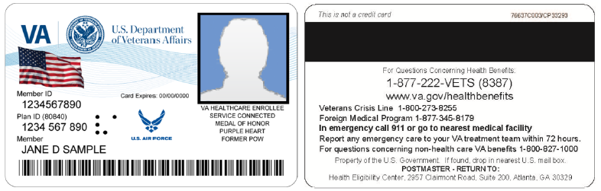

Figure 2‑1: Example of what the VHIC looks like

## Accessing the VHIC Application

VHIC is a web based application which users will access via a web browser. The recommended browser is Internet Explorer (currently version 11). The VHIC URL is <https://vic.iam.va.gov/VIC/faces/index.jsf> and is **case sensitive** – it must be entered exactly as shown. After successfully logging in to the VHIC application, users should bookmark this site for easy access in the future. Instructions on how to do just that can be found here: <http://windows.microsoft.com/en-us/internet-explorer/add-view-organize-favorites#ie=ie-11-win-7>.

The best time to bookmark the site is after the user is in the application itself rather than attempting to bookmark the Login screen.

## Browser

Once users are logged into their VA desktop, they will access VHIC using Internet Explorer (IE) by either entering the URL listed above or via the bookmark saved during an earlier session. Please do **NOT** use the *Refresh* button at the top of your browser window if you mistype the VHIC URL. The *Refresh* button will redirect you to the VA website. Please re-enter the VHIC URL and try again.

### Browser Incompatibility Issue

In some instances, users may experience image misplacement or misalignment. This is most likely due to the current browser compatibility settings. You will want to ensure that the browser is not set to Compatibility View.

Examples of Image Misplacement and Other Misalignments:

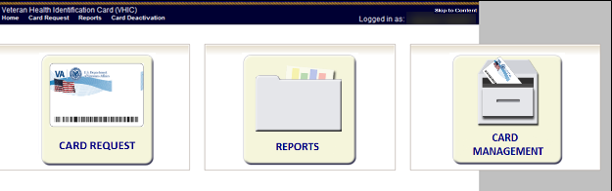

Figure 2‑2: Over-sized icon buttons on the Home Screen

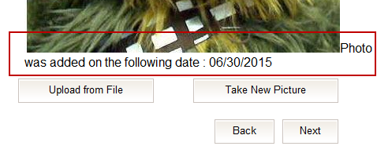

Figure 2‑3: Words wrapping around the displayed photo on Step 3

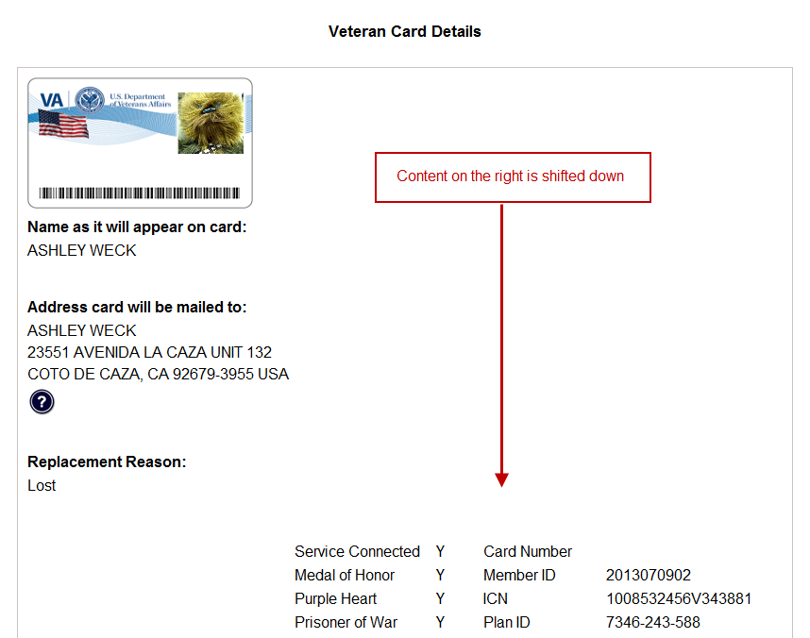

Figure 2‑4: Content on the right of the Step 5 screen is shifted down

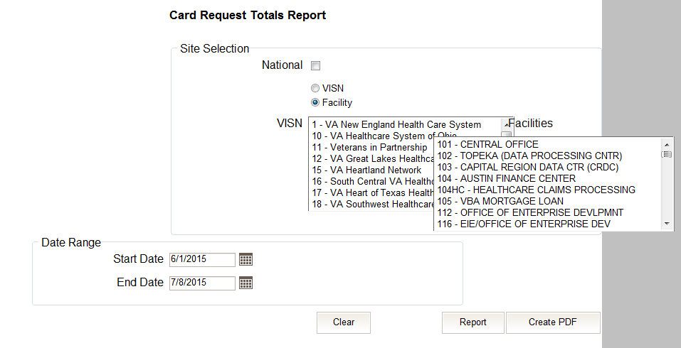

Figure 2‑5: Both the VISN and Facility selection lists are displayed and shifted to the right

If you are experiencing misalignment issues, follow these steps to verify/update your browser compatibility settings:

1. With Internet Explorer open, right click in the blue area at the top of the browser window.
2. Click on Command Bar to display the Command Tool Bar.

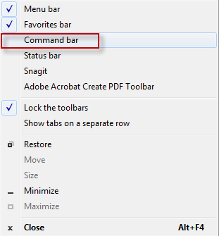

Figure 2‑6: Internet Explorer's Toolbar Menu

1. Click on the Tools menu button.



Figure 2‑7: Tools Menu button

1. Click on Compatibility View Settings.

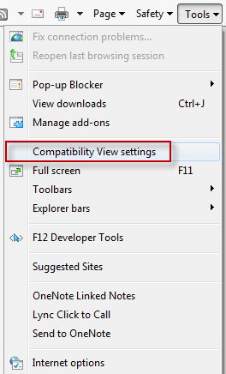

Figure 2‑8: Tools drop-down menu

1. Uncheck the box next to Display intranet sites in Compatibility View.

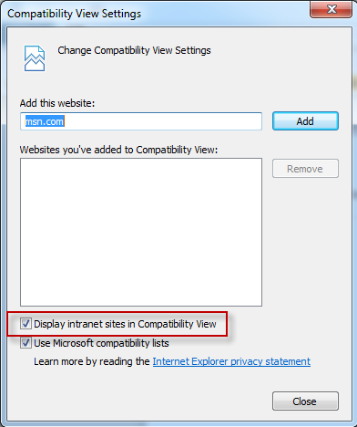

Figure 2‑9: Compatibility View Settings screen

1. Click the Close button.

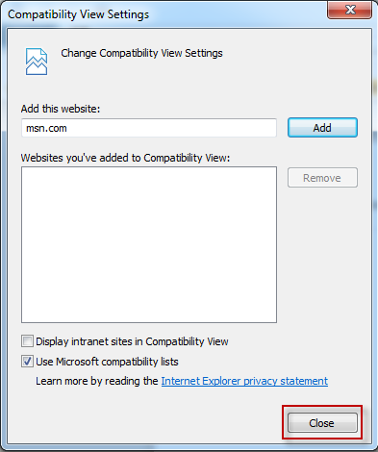

Figure 2‑10: Compatibility View Settings Screen - Close

*****NOTE:*** *Compatibility mode does need to be turned on in order to access other applications such as Notes in NUMI’s CERMe and the Beneficiary Travel Dashboard. You can turn compatibility mode back on by following the above directions and checking the Display intranet sites in Compatibility View checkbox*.

## Proper Navigation of the VHIC Application

The correct way to navigate through the VHIC application is to use the buttons that are located at the bottom of each screen instead of using the Browser’s built in Back button. Please do **NOT** use the *Back* button at the top of your browser window to navigate back to a previous screen; this will cause errors to occur.

The VHIC user can also navigate to the different features within the VHIC application by clicking on one of the navigation links located in the header near the top left of the screen. The user’s assigned role will determine which links are available as seen below. To see the full home screens for each user role, refer to the 3.3 System Menu section.



Figure 2‑11: VHIC Administrator and VHIC Technical Administrator (Tier 3) menu



Figure 2‑12: VHIC Associate and VHIC Supervisor menu



Figure 2‑13: VHIC Auditor and VHIC Read-Only User menu

**NOTE:** The “Skip To Content” link is a Section 508 compliance feature that skips repetitive navigation links so that page content can be quickly accessed.

## Roles within VHIC

The VHIC application is built to accommodate a specific set of pre-established user roles. During the provisioning process, the VHIC user will have a role assigned to them, which will determine what aspects of the VHIC application are available to them. The following breaks down the specific roles and the areas of access that accompany each role.

If, while utilizing the VHIC application, a user finds they do not have access to items they feel they should have access to or find that they have access to items they should not, based on the definitions listed below, the VHIC user should report this information to their VHIC Supervisor. The VHIC Supervisor should then verify that the proper role has been assigned.

### VHIC Associate

The VHIC Associate role shall be assigned to individuals responsible for processing card requests and resolving card request issues. Associates have the ability to create card requests and have access to a limited number of reports.

### VHIC Supervisor

The VHIC Supervisor shall automatically inherit all access and privileges given to the VHIC Associate. The VHIC Supervisor role is allowed to submit a request for user access to the VHIC application. VHIC Supervisors have the ability to create card requests and have access to most available reports (excluding national versions).

### VHIC Administrator

The VHIC Administrator role is reserved for the VHIC Business (HEC) team members responsible for the creation and maintenance of all other VHIC accounts/roles. The VHIC Administrator shall automatically inherit privileges given to the VHIC Supervisor. Administrators have the ability to create card requests, deactivate cards, and have access to all available reports.

### VHIC Technical Administrator (Tier 3)

The VHIC Technical Administrator (Tier 3) automatically inherits all access and privileges given to the VHIC Administrator. Technical Administrators (Tier 3) have the ability to create card requests and have access to all available reports as well as access to the Administration page.

### VHIC Auditor

The VHIC Auditor role shall be assigned to users with read-only access to the VHIC System. The VHIC Auditor does not have the ability to create card requests, but does have access to all available reports.

### VHIC Read-Only User

The VHIC Read-Only User role shall be assigned to users with read-only access to the VHIC System. The VHIC Read-Only user does not have the ability to create card requests, but does have access to a limited number of reports.

# Getting Started

## Single Sign-On Internal (SSOi)

Once users are logged into their VA desktop, they will access VHIC using Internet Explorer (IE) by either entering the URL listed above or via the bookmark saved during an earlier session.

Users will be presented with the Single Sign On – internal (SSOi) login screen (*shown below*).

Here the VHIC user will need to use their PIV card to log into the VHIC application.

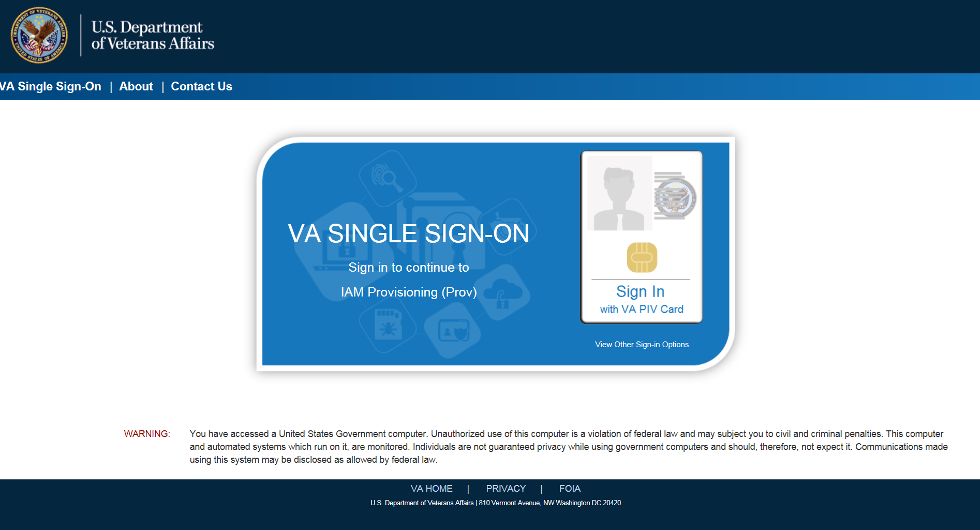

Figure 3‑1: SSOi Login Screen

## Logging On

The VHIC application is built to accommodate a specific set of pre-established user roles. During the provisioning process, the VHIC user will have a role assigned to them, which will determine what aspects of the VHIC application are available to them. The roles are listed below. For more information on the areas of access that accompanies each role, please refer to section 2.4.

* VHIC Associate
* VHIC Supervisor
* VHIC Administrator
* VHIC Technical Administrator (Tier 3)
* VHIC Auditor
* VHIC Read-Only User

## System Menu

Depending on the VHIC users’ role, they will be presented different Home screens upon logging to the VHIC application.

### VHIC Administrator and Technical Administrator Tier 3

The VHIC Administrator and VHIC Technical Administrator Tier 3 users will be presented with three menu options: Card Requests, Reports and Card Management. They can navigate to each of these application modules by either clicking on one of the links located in the header at the top left of the screen or by clicking on one of the icon buttons in the middle of the screen.

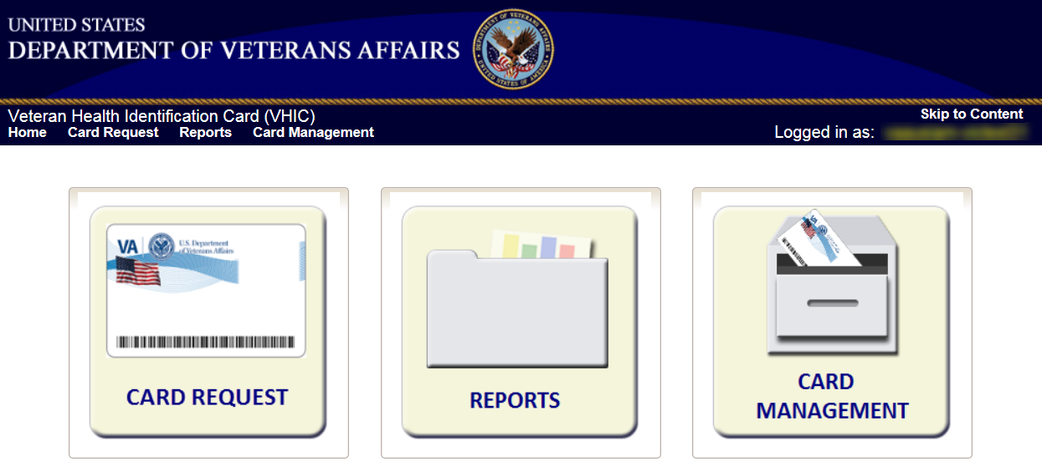

Figure 3‑2: VHIC Administrator and VHIC Technical Administrator (Tier 3) Home screen

### VHIC Associate and Supervisor

The VHIC Associate and VHIC Supervisor users will be presented with two menu options: Card Requests and Reports. They can navigate to each of these application modules by either clicking on one of the links located in the header at the top left of the screen or by clicking on one of the icon buttons in the middle of the screen.

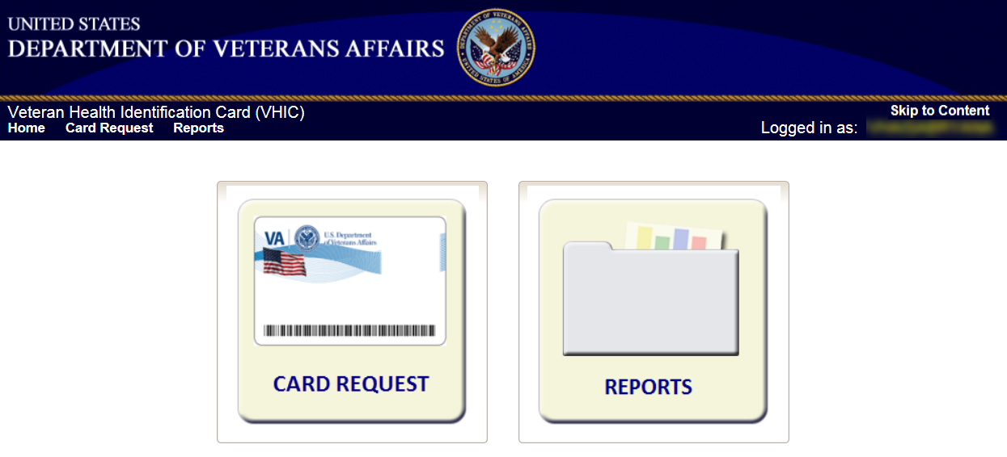

Figure 3‑3: VHIC Associate and VHIC Supervisor Home screen

### VHIC Auditor and Read-Only User

The VHIC Auditor and VHIC Read-Only users will be presented with the Reports menu option. They can navigate to Reports by clicking on the icon button in the middle of the screen.

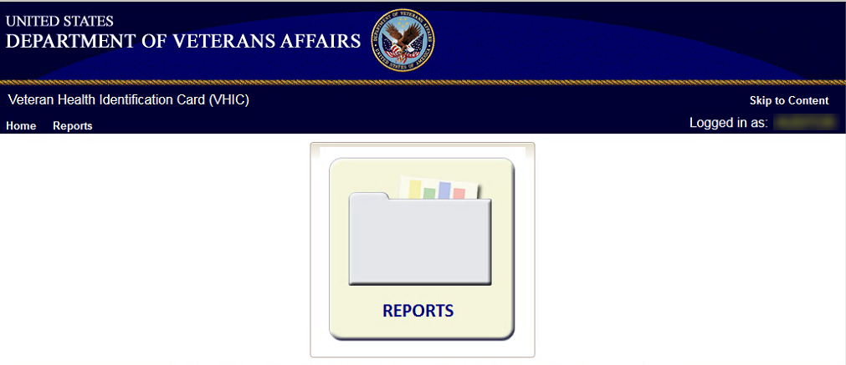

Figure 3‑4: VHIC Auditor and VHIC Read-Only User Home screen

## Changing User ID and Password

If you have any questions or need help with your User ID or your Password; call the Enterprise Service Desk at 855-673-4357 and then select option 1 (Account or Password Reset), then option 1.

# Before Requesting a VHIC Card

For detailed step-by-step process of how to access and complete the Identity Proofing Verification task in the Identity Management Toolkit application, please refer to section 4 in the **Veteran Health Identification Card (VHIC 4.8) User Guide - Volume 1 - Card Requests** **– All Users** document.

# Creating a VHIC Card – The Card Request Process

For a step-by-step process on how to navigate through the Card Request screens in the VHIC application and an explanation of the process involved in creating a VHIC for a Veteran, please refer to section 5 in the **Veteran Health Identification Card (VHIC 4.8) User Guide - Volume 1 - Card Requests** **– All Users** document.

## Requesting a VHIC for a Veteran Within Ten (10) Days of a Previous VHIC Request

VHIC Supervisors and VHIC Associates will not be able to request a new VHIC for a Veteran if there has been a previous request made within the past ten (10) days. They will be shown a message on Step 2 of the VHIC card request process stating:

“This Veteran has a recent VHIC request in process. Please remind the Veteran the VHIC should be received with 10 days after the request was submitted.”

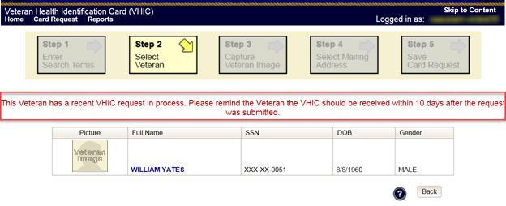

Figure 5‑1: Replacement Card has been requested within the past 10 days

If for some reason a new VHIC request must be made to include any changes, **ONLY** the **VHIC Administrator** will be able to submit a new card request within 10 days of the previous card request.

In this instance, the VHIC user will need to submit a request to the **VHA HEC VHIC Program Team** mail group via an encrypted message.

Information to include in the request is listed below:

* Veteran’s First and Last Name
* Date of Birth
* SSN
* Site Point of Contact
* Reason for needing a new card requested within 10 days of the previous request.

Using the information provided in the request sent to the **VHA HEC VHIC Program Team**,The **VHIC Administrator** would be able to submit a new card request for the Veteran indicated. The card request will follow the same guidelines and steps as creating a Replacement Card Request that is covered in section *4.4 Replacement VHIC: Veteran Level 2 Proofed through Identity Management Toolkit* of the **Veteran Health Identification Card (VHIC 4.8) User Guide - Volume 1 - Card Requests** **– All Users** document.

# Card Management – The Card Deactivation Process

Table 3: Who can deactivate a card?

| At a Glance… |  |
| --- | --- |
| Who can deactivate a card? | *Administrator, Tech Admin (Tier 3)* |

This section will walk the VHIC Administrator through the process of deactivating all cards for a Veteran.

The card deactivation process follows numbered steps shown next.

1. Enter Search Terms
2. Select Veteran
3. Select Deactivation Reason
4. Confirm Deactivation Request
5. Request a Replacement Card (when applicable)
6. Verifying Card Deactivation

These steps are fully explained below. We will now walk through the steps required to complete a VHIC card deactivation request for each of the available deactivation reasons.

The following is a list of reasons that are available to the VHIC Administrator for deactivating cards.

* Cancelled/Declined
* Damaged
* Deceased
* Identity Theft
* Lost
* Other
* Stolen

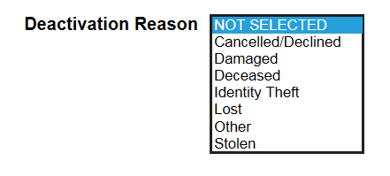

Figure 6‑1: Card Deactivation Reasons drop-down menu

The VHIC Administrator will have the option to request a replacement card at the end of the card deactivation process in select instances.

The deactivation reasons that will allow the Administrator to request a new card are:

* Damaged
* Lost
* Stolen

## Cancelled/Declined

### Accessing Card Deactivation

When the VHIC Administrator logs in to the VHIC application, they are presented with three menu options: Card Request, Reports, and Card Management. The Administrator can click either on the links in the header at the top of the screen or on the icon buttons in the middle of the screen.

To begin the Card Deactivation process, the VHIC Administrator would click on either the Card Management link or the Card Management icon button.

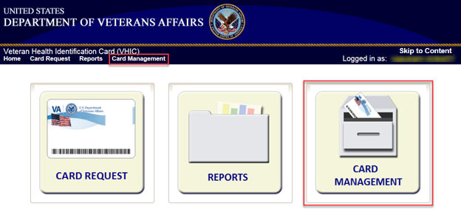

Figure 6‑2: VHIC Administrator Home screen; click Card Management

### Step 1: Enter Search Terms

The first step in the process is to find the Veteran in the system. This is accomplished by entering enough search criteria to trigger a match within Master Veteran Index (MVI). The top of the screen offers guidance regarding the set of traits recommended to ensure the best match is found. These are guidelines and not necessarily the required set of traits that must be entered.

However, for optimal search results, copy the Veteran’s ICN from Toolkit and paste it into the ICN field on this screen.

Other search methods include:

* The Member ID from the front of the Veteran’s VHIC
* Last Name, First Name, DOB and SSN



***NOTE:*** *If using LN/FN/DOB/SSN combination, at a minimum, supply the Veteran's Last Name, plus values from at least two of the other three sections (Person, Address, and Identification).*

The more traits entered, the more likely a match will be returned. Additional guidance is also available on-screen by clicking on the blue circle containing a question mark.



Figure 6‑3: Help icon

This type of help is available throughout the application and will provide additional detail or clarification for that particular step or section.

Once the information has been entered into the required fields, click on **[Search]** to proceed to the next step.

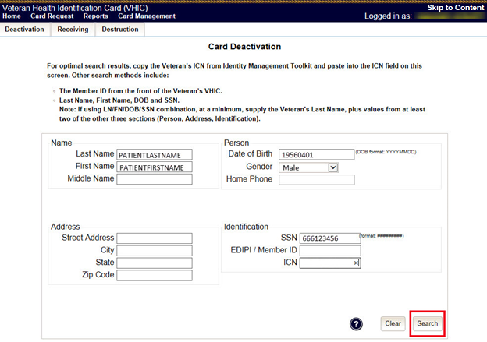

Figure 6‑4: Card Management Deactivation Home screen. Enter Search Terms screen

Various error messages can be received throughout the Card Deactivation process. If the search yields no results, a message will be displayed above the search fields.

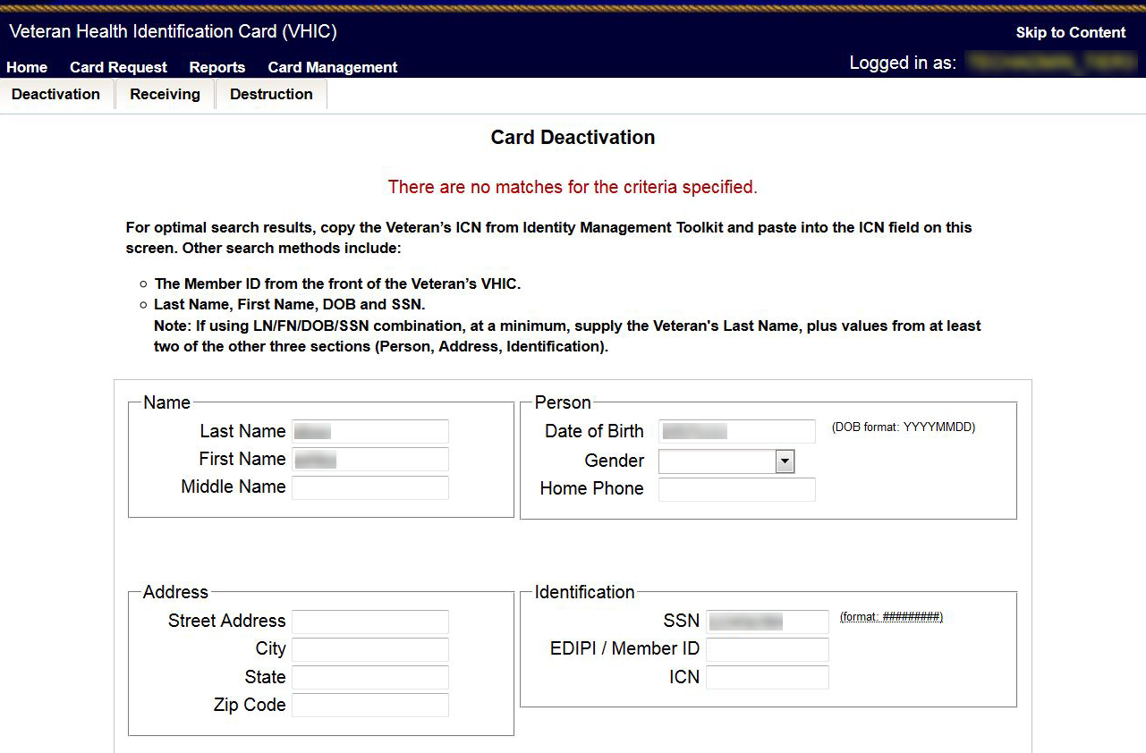

Figure 6‑5: Enter Search Terms screen - No Match Found error

The user can then verify that the information entered is correct or make corrections as needed as well as add more information to increase the likelihood of finding a match.

### Step 2: Select Veteran

If the search was successful and a possible match has been found, the results of that search will be displayed on screen. From the list provided (up to 10 matches may be returned), select the appropriate Veteran by clicking on the **Veteran’s name** which is hyperlinked.

If the correct Veteran is not in the list, click the **[Back]** button and verify the traits entered are correct. If the traits are correct, try adding additional information to aid in triggering a match.

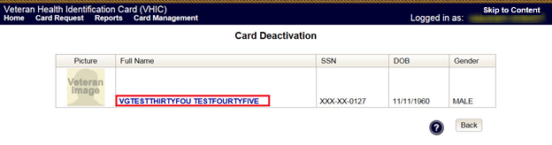

Figure 6‑6: Card Deactivation Select Veteran screen

### Select Deactivation Reason

Once the Administrator has selected the correct Veteran, the next step in the process is to select the reason for deactivating all the VHIC cards for this Veteran. Choose from one of the several deactivation reasons VHIC provides.

Select the *Cancelled/Declined* reason for deactivating the VHIC cards for this Veteran from the drop down menu.

Click on the **[Deactivate]** button to continue to the next step.

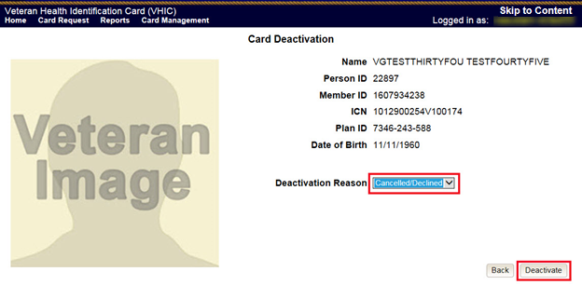

Figure 6‑7: Select Deactivation Reason screen

### Confirm Deactivation Request

The VHIC application will ask the user to confirm that they really want to deactivate all of the cards for this Veteran.

Click the **[OK]** button on the pop up window to continue.

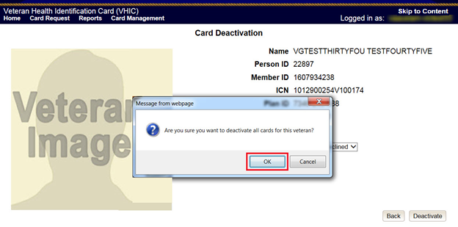

Figure 6‑8: Confirm Deactivation pop-up window

This screen shows that the Card Deactivation was completed successfully.

The selected deactivation reason will be displayed on this screen.

Since *Cancelled/Declined* was the deactivation reason selected, the VHIC Admin is not presented with the option to request a new card for the Veteran.

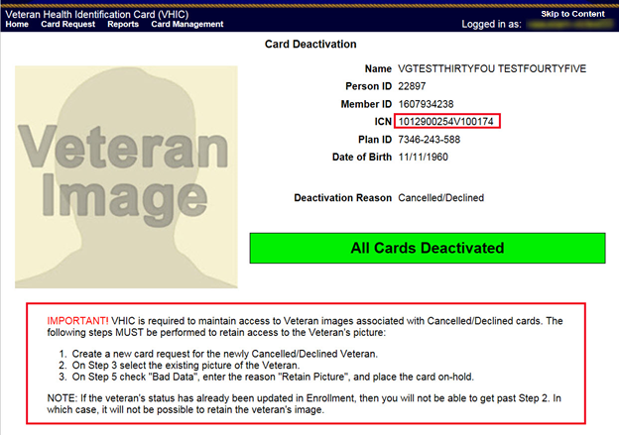

Figure 6‑9: All Cards Deactivated - Cancelled/Declined

### Verifying Card Deactivation

The VHIC Administrator can verify that all of the cards for that Veteran have been deactivated by looking at the Card History report. To see all of the cards for a Veteran, search by using the Veteran’s Person ID, which was displayed on the last step of the card deactivation process.

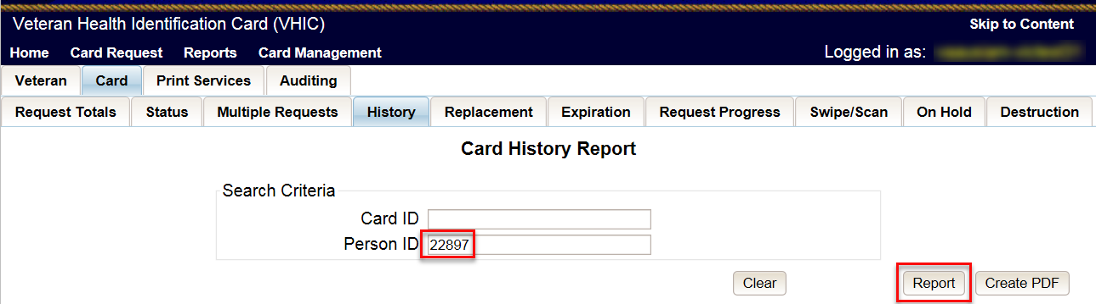

Figure 6‑10: Card History Report Query Screen

When looking at the Card History report, the user will see that the *Current Card Status* has been updated to *Deactivated* and the *Current MVI Status* has been updated to *Unlinked*.

The user will also see the messages for *Deactivated* and *MVI Correlation Unlinked* in the Message history section.

The Deactivation Reason field will also be populated with the deactivation reason that was selected during the card deactivation process.

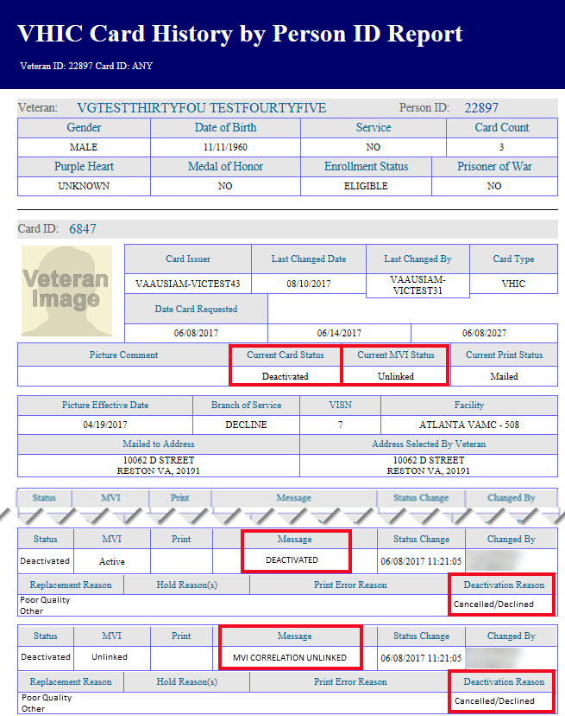

Figure 6‑11: Card History Report - Cancelled/Declined

### Saving a Card Request On-Hold to Retain Picture (For Cancelled/Declined enrollment only)

The next step in this process is to create a card request and manually save it On-Hold in order to be able to retain the Veteran’s picture in MVI.

On Step 1 of the Card request process, Enter the *Veteran’s ICN* that was copied from the Card Deactivation Confirmation screen and click the **[Search]** button.

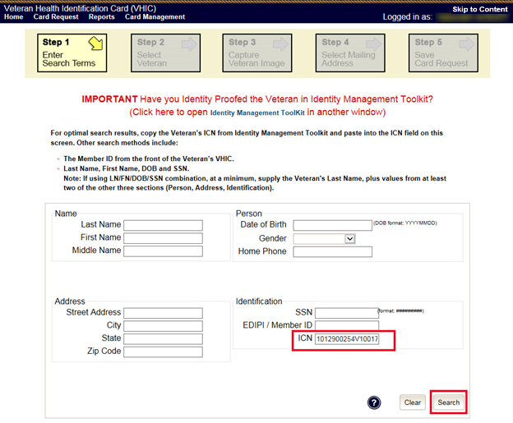

Figure 6‑12: Step 1: Enter Search Terms

Select the Veteran you wish to create the card request for by clicking on the **Veteran’s Name**.

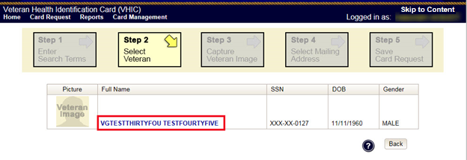

Figure 6‑13: Step 2: Select Veteran

Click the **[Next]** button to reuse the existing photo.

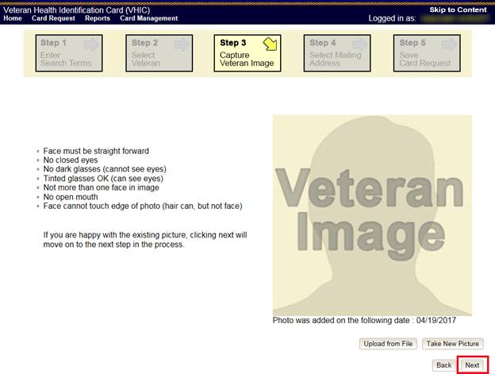

Figure 6‑14: Step 3: Capture Veteran Image - Reuse Photo, Click Next button

Confirm that you want to use the existing photo by clicking on the **[OK]** button.

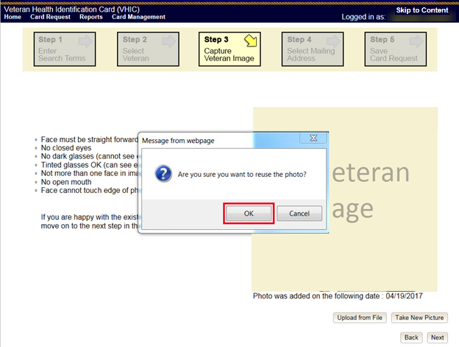

Figure 6‑15: Step 3: Confirm Reuse of Photo by clicking the OK button

On the Step 4: Select Mailing Address screen, select *“Incorrect Information”* from the drop down menu for *Replacement Reason*, and *“Other”* from the drop down menu that appears for *Incorrect Informatio*n. Click the **[Next]** button to continue.

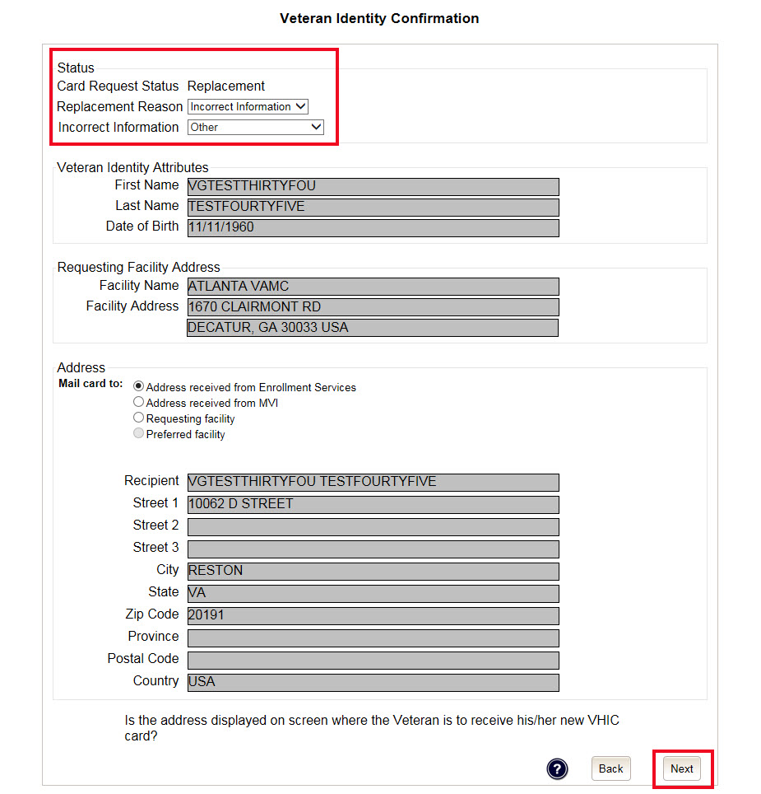

Figure 6‑16: Step 4: Select Mailing Address - Replacement Reason: Incorrect Information - Other

On the Step 5: Save Card Request screen, click on the checkbox next to *Bad Data* and enter “*Retain Picture*” in the *Details* text box. Click on the **[Hold]** button to save the card request.

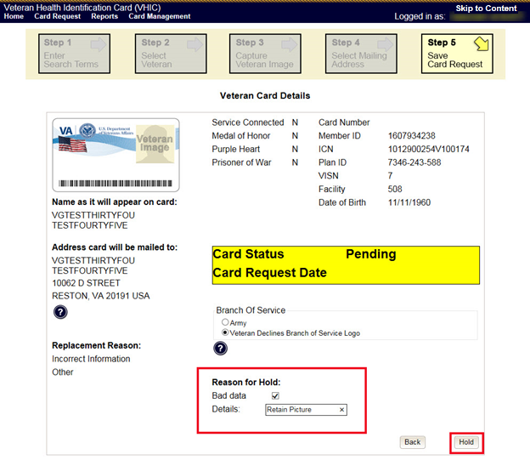

Figure 6‑17: Step 5: Save Card Request - Select Bad Data - Details: Retain Picture

Confirm that the card request has been saved on hold by noting the color bar has gone from yellow to orange, and that the **Reason for Hold** is displayed as “*Bad Data: Retain Picture*.”

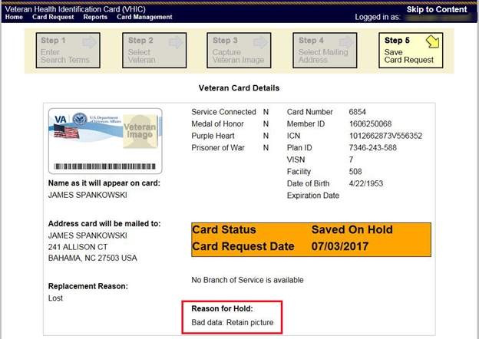

Figure 6‑18: Step 5: Save Card Request - Saved on Hold - Reason for Hold - Bad Data: Retain Picture

The VHIC Administrator can verify that the card just requested for that Veteran has been saved on hold with the Bad Data: Retain Picture hold reason by looking at the Card History report. To see the card history for this card, search by using the Card ID that was displayed on the last step of the card request process.

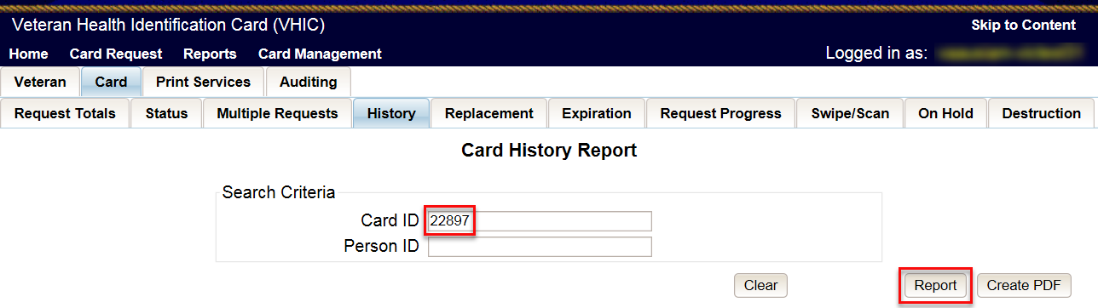

Figure 6‑19: Card History Report Query Screen

When looking at the Card History report, the user will see that the *Current Card Status* has been updated to *On Hold* and the *Current MVI Status* has been updated to *Active*.

The user will also see the Replacement Reason field is now showing “*Incorrect Information-* Other” and the Hold Reason is listed as “*Bad Data – Retain Picture*” in the Message history section.

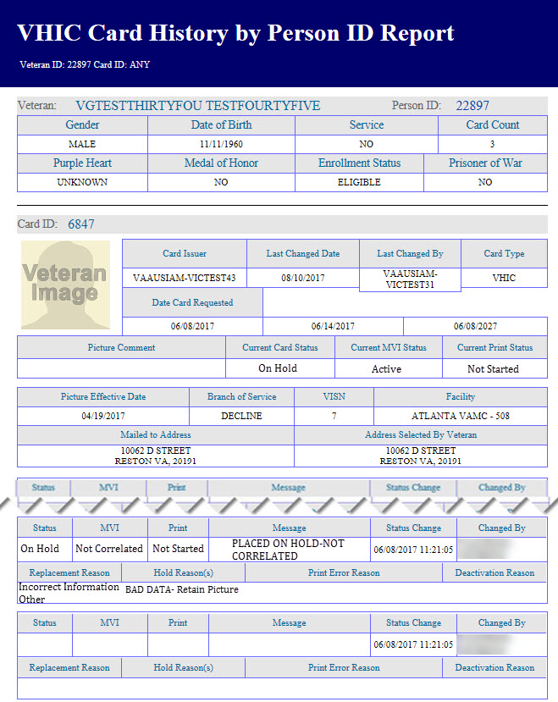

Figure 6‑20: Card History Report - Hold Reason: Bad Data - Retain Picture

## Damaged

### Accessing Card Deactivation

When the VHIC Administrator logs in to the VHIC application, they are presented with three menu options: Card Request, Reports, and Card Management. The Administrator can click either on the links in the header at the top of the screen or on the icon buttons in the middle of the screen.

To begin the Card Management process, the VHIC Administrator would click on either the Card Management link or the Card Management icon button.

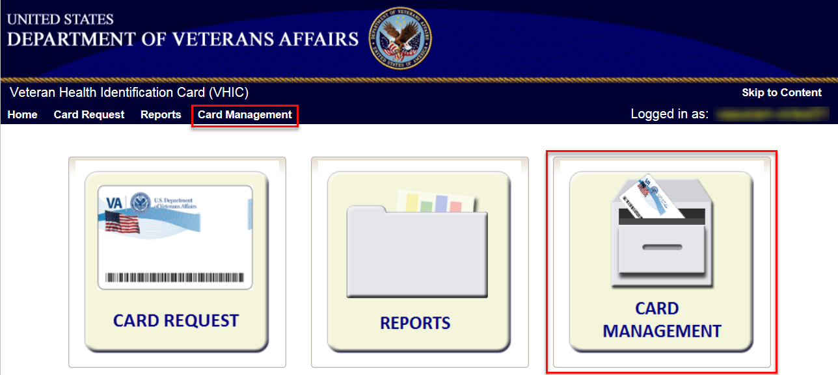

Figure 6‑21: VHIC Administrator Home screen; click Card Management

### Step 1: Enter Search Terms

The first step in the process is to find the Veteran in the system. This is accomplished by entering enough search criteria to trigger a match within Master Veteran Index (MVI). The top of the screen offers guidance regarding the set of traits recommended to ensure the best match is found. These are guidelines and not necessarily the required set of traits that must be entered.

However, for optimal search results, copy the Veteran’s ICN from Toolkit and paste it into the ICN field on this screen.

Other search methods include:

* The Member ID from the front of the Veteran’s VHIC
* Last Name, First Name, DOB and SSN

***NOTE:*** *If using LN/FN/DOB/SSN combination, at a minimum, supply the Veteran's Last Name, plus values from at least two of the other three sections (Person, Address, and Identification).*

The more traits entered, the more likely a match will be returned. Additional guidance is also available on-screen by clicking on the blue circle containing a question mark.



Figure 6‑22: Help icon

This type of help is available throughout the application and will provide additional detail or clarification for that particular step or section.

Once the information has been entered into the required fields, click on **[Search]** to proceed to the next step.

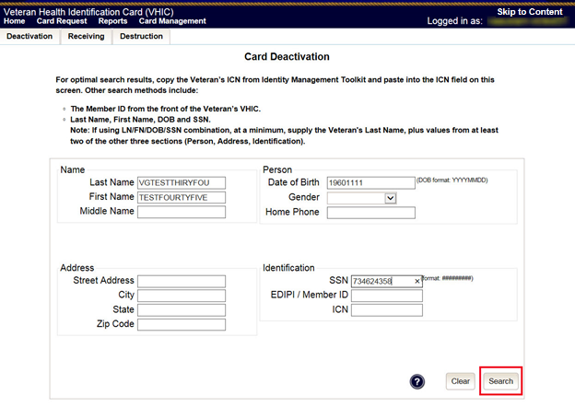

Figure 6‑23: Card Deactivation Enter Search Terms screen

### Step 2: Select Veteran

If the search was successful and a possible match has been found, the results of that search will be displayed on screen. From the list provided (up to 10 matches may be returned), select the appropriate Veteran by clicking on the **Veteran’s name** which is hyperlinked.

If the correct Veteran is not in the list, click the **[Back]** button and verify the traits entered are correct. If the traits are correct, try adding additional information to aid in triggering a match.

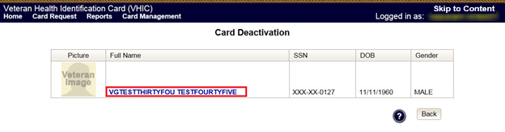

Figure 6‑24: Card Deactivation Select Veteran screen

### Select Deactivation Reason

Once the Administrator has selected the correct Veteran, the next step in the process is to select the reason for deactivating all the VHIC cards for this Veteran. Choose from one of the several deactivation reasons VHIC provides.

Select *Damaged* as the reason for deactivating the VHIC cards for this Veteran from the drop down menu.

Click on the **[Deactivate]** button to continue to the next step.

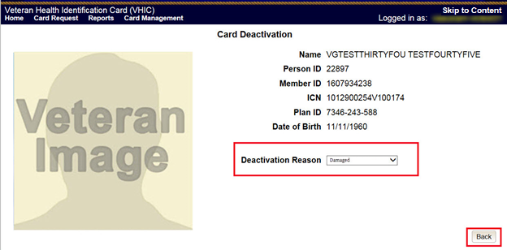

Figure 6‑25: Select Deactivation Reason screen

### Confirm Deactivation Request

The VHIC application will ask the user to confirm that they really want to deactivate all of the cards for this Veteran.

Click the **[OK]** button on the pop up window to continue.

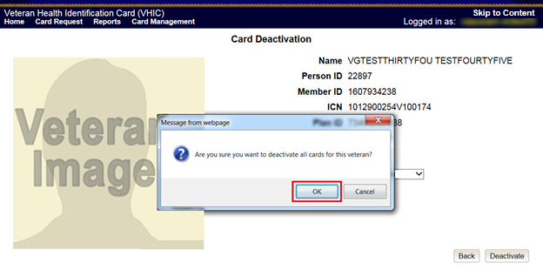

Figure 6‑26: Confirm Deactivation pop-up window

This screen shows that the Card Deactivation was completed successfully.

The selected deactivation reason will be displayed on this screen.

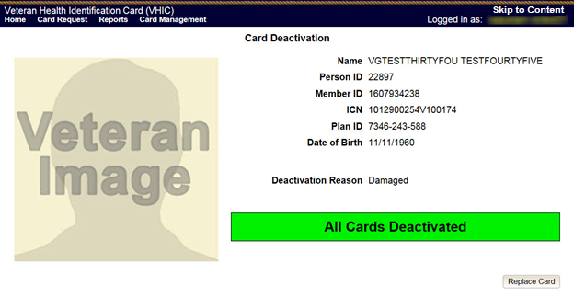

Figure 6‑27: All Cards Deactivated - Damaged

### Request a Replacement Card

The VHIC Administrator will have the option to request a replacement card at the end of the card deactivation process in select instances. Since *Damaged* was the deactivation reason selected, the VHIC Admin is presented with the option to request a new card for the Veteran.

To request a replacement card, click the **[Replace a Card]** button.

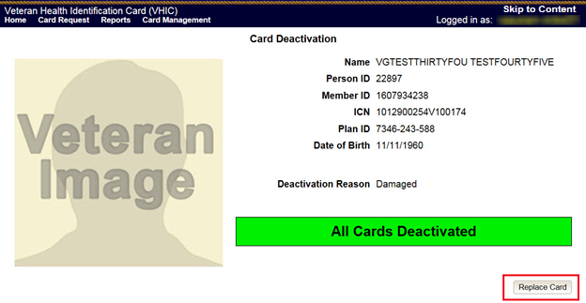

Figure 6‑28: Replace Card

This will take the user to *Step 3: Capture Veteran Image* of the card request process.

Click **[Next]** to reuse the existing photo for this Veteran. Then complete the card request process following the current procedures.

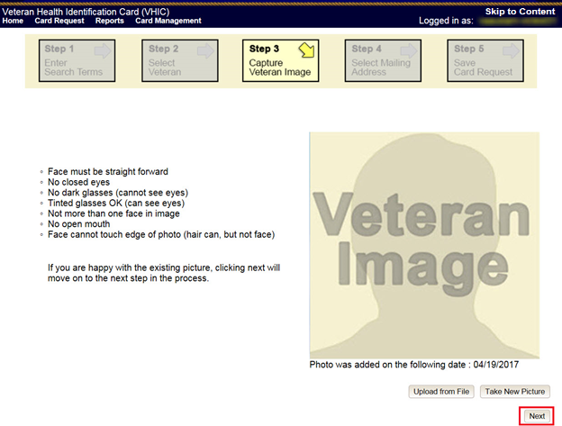

Figure 6‑29: Step 3 Capture Veteran Image screen

### Verifying Card Deactivation

The VHIC Administrator can verify that all of the cards for that Veteran have been deactivated by looking at the Card History report. To see all of the cards for a Veteran, search by using the Veteran’s Person ID, which was displayed on the last step of the card deactivation process.

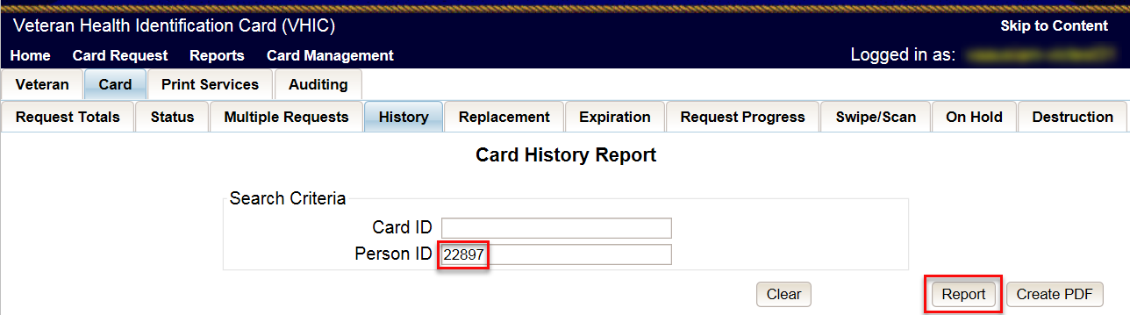

Figure 6‑30: Card History Report Query Screen

When looking at the Card History report, the user will see that the *Current Card Status* has been updated to *Deactivated* and the *Current MVI Status* has been updated to *Unlinked*.

The user will also see the messages for *Deactivated* and *MVI Correlation Unlinked* in the Message history section.

The Deactivation Reason field will also be populated with the deactivation reason that was selected during the card deactivation process.

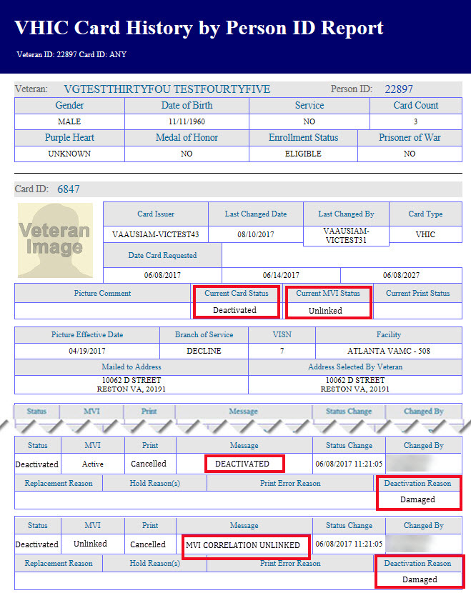

Figure 6‑31: Card History Report – Damaged

## Deceased

### Accessing Card Deactivation

When the VHIC Administrator logs in to the VHIC application, they are presented with three menu options: Card Request, Reports, and Card Management. The Administrator can click either on the links in the header at the top of the screen or on the icon buttons in the middle of the screen.

To begin the Card Management process, the VHIC Administrator would click on either the Card Management link or the Card Management icon button.



Figure 6‑32: VHIC Administrator Home screen; click Card Management

### Step 1: Enter Search Terms

The first step in the process is to find the Veteran in the system. This is accomplished by entering enough search criteria to trigger a match within Master Veteran Index (MVI). The top of the screen offers guidance regarding the set of traits recommended to ensure the best match is found. These are guidelines and not necessarily the required set of traits that must be entered.

However, for optimal search results, copy the Veteran’s ICN from Toolkit and paste it into the ICN field on this screen.

Other search methods include:

* The Member ID from the front of the Veteran’s VHIC
* Last Name, First Name, DOB and SSN

***NOTE:*** *If using LN/FN/DOB/SSN combination, at a minimum, supply the Veteran's Last Name, plus values from at least two of the other three sections (Person, Address, and Identification).*

The more traits entered, the more likely a match will be returned. Additional guidance is also available on-screen by clicking on the blue circle containing a question mark.



Figure 6‑33: Help icon

This type of help is available throughout the application and will provide additional detail or clarification for that particular step or section.

Once the information has been entered into the required fields, click on **[Search]** to proceed to the next step.

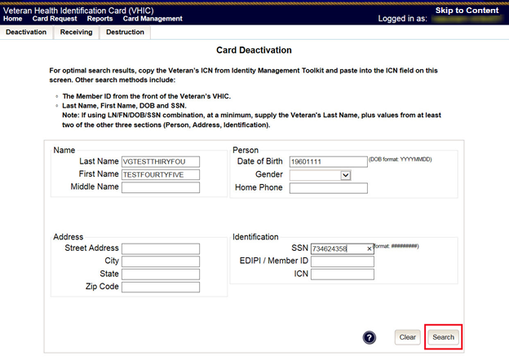

Figure 6‑34: Card Deactivation Enter Search Terms screen

### Step 2: Select Veteran

If the search was successful and a possible match has been found, the results of that search will be displayed on screen. From the list provided (up to 10 matches may be returned), select the appropriate Veteran by clicking on the **Veteran’s name** which is hyperlinked.

If the correct Veteran is not in the list, click the **[Back]** button and verify the traits entered are correct. If the traits are correct, try adding additional information to aid in triggering a match.

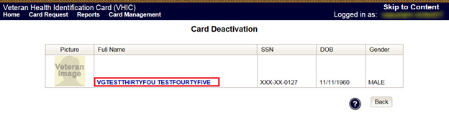

Figure 6‑35: Card Deactivation Select Veteran screen

### Select Deactivation Reason

Once the Administrator has selected the correct Veteran, the next step in the process is to select the reason for deactivating all the VHIC cards for this Veteran. Choose from one of the several deactivation reasons VHIC provides.

Select the *Deceased* as the reason for deactivating the VHIC cards for this Veteran from the drop down menu.

Click on the **[Deactivate]** button to continue to the next step.

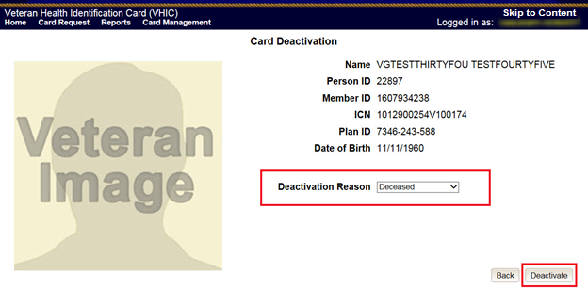

Figure 6‑36: Select Deactivation Reason screen

### Confirm Deactivation Request

The VHIC application will ask the user to confirm that they really want to deactivate all of the cards for this Veteran.

Click the **[OK]** button on the pop up window to continue.

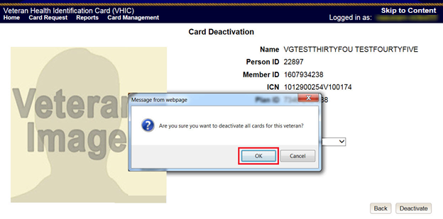

Figure 6‑37: Confirm Deactivation pop-up window

This screen shows that the Card Deactivation was completed successfully.

The selected deactivation reason will be displayed on this screen.

Since *Deceased* was the deactivation reason selected, the VHIC Admin is not presented with the option to request a new card for the Veteran.

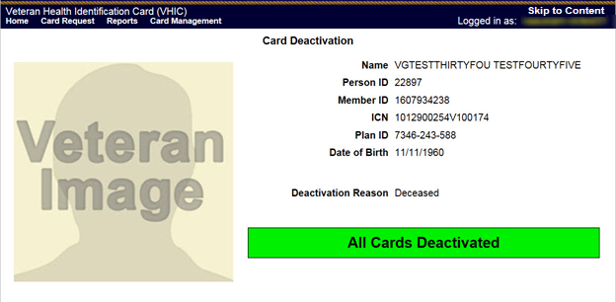

Figure 6‑38: All Cards Deactivated - Deceased

### Verifying Card Deactivation

The VHIC Administrator can verify that all of the cards for that Veteran have been deactivated by looking at the Card History report. To see all of the cards for a Veteran, search by using the Veteran’s Person ID, which was displayed on the last step of the card deactivation process.



Figure 6‑39: Card History Report Query Screen

When looking at the Card History report, the user will see that the *Current Card Status* has been updated to *Deactivated* and the *Current MVI Status* has been updated to *Unlinked*.

The user will also see the messages for *Deactivated* and *MVI Correlation Unlinked* in the Message history section.

The Deactivation Reason field will also be populated with the deactivation reason that was selected during the card deactivation process.

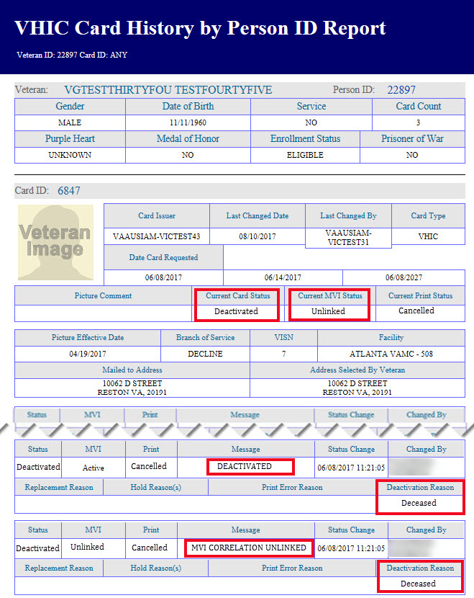

Figure 6‑40: Card History Report - Deceased

## Identity Theft

### Accessing Card Management

When the VHIC Administrator logs in to the VHIC application, they are presented with three menu options: Card Request, Reports, and Card Management. The Administrator can click either on the links in the header at the top of the screen or on the icon buttons in the middle of the screen.

To begin the Card Deactivation process, the VHIC Administrator would click on either the Card Management link or the Card Management icon button.



Figure 6‑41: VHIC Administrator Home screen; click Card Management

### Step 1: Enter Search Terms

The first step in the process is to find the Veteran in the system. This is accomplished by entering enough search criteria to trigger a match within Master Veteran Index (MVI). The top of the screen offers guidance regarding the set of traits recommended to ensure the best match is found. These are guidelines and not necessarily the required set of traits that must be entered.

However, for optimal search results, copy the Veteran’s ICN from Toolkit and paste it into the ICN field on this screen.

Other search methods include:

* The Member ID from the front of the Veteran’s VHIC
* Last Name, First Name, DOB and SSN

***NOTE:*** *If using LN/FN/DOB/SSN combination, at a minimum, supply the Veteran's Last Name, plus values from at least two of the other three sections (Person, Address, and Identification).*

The more traits entered, the more likely a match will be returned. Additional guidance is also available on-screen by clicking on the blue circle containing a question mark.



Figure 6‑42: Help icon

This type of help is available throughout the application and will provide additional detail or clarification for that particular step or section.

Once the information has been entered into the required fields, click on **[Search]** to proceed to the next step.

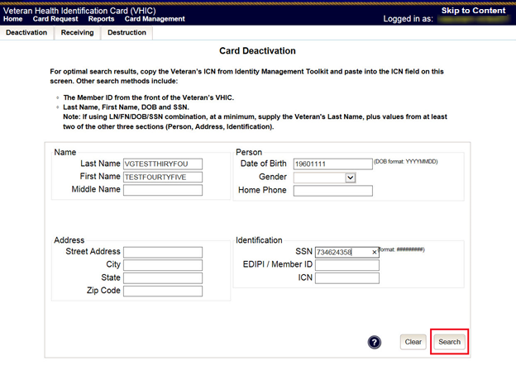

Figure 6‑43: Card Management Enter Search Terms screen

### Step 2: Select Veteran

If the search was successful and a possible match has been found, the results of that search will be displayed on screen. From the list provided (up to 10 matches may be returned), select the appropriate Veteran by clicking on the **Veteran’s name** which is hyperlinked.

If the correct Veteran is not in the list, click the **[Back]** button and verify the traits entered are correct. If the traits are correct, try adding additional information to aid in triggering a match.

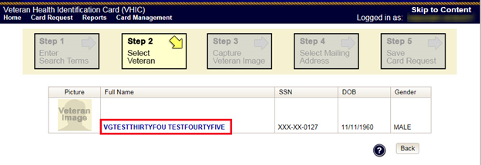

Figure 6‑44: Card Deactivation Select Veteran screen

### Select Deactivation Reason

Once the Administrator has selected the correct Veteran, the next step in the process is to select the reason for deactivating all the VHIC cards for this Veteran. Choose from one of the several deactivation reasons VHIC provides.

Select the *Identity Theft* as the reason for deactivating the VHIC cards for this Veteran from the drop down menu.

Click on the **[Deactivate]** button to continue to the next step.

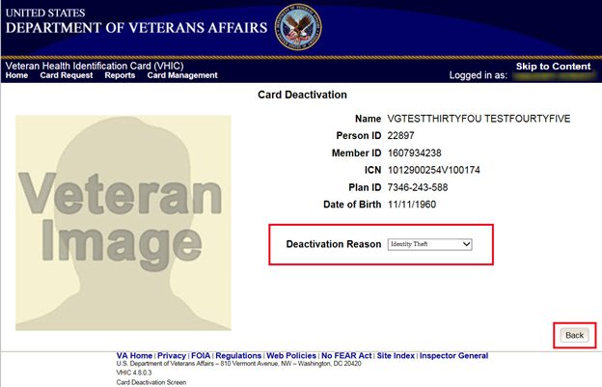

Figure 6‑45: Select Deactivation Reason screen

### Confirm Deactivation Request

The VHIC application will ask the user to confirm that they really want to deactivate all of the cards for this Veteran.

Click the **[OK]** button on the pop up window to continue.

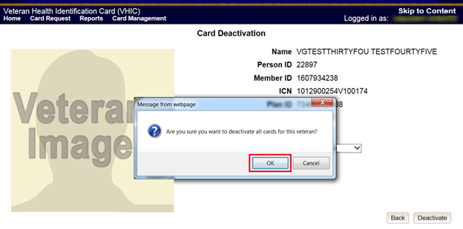

Figure 6‑46: Confirm Deactivation pop-up window

This screen shows that the Card Deactivation was completed successfully.

The selected deactivation reason will be displayed on this screen.

Since *Identity Theft* was the deactivation reason selected, the VHIC Admin is not presented with the option to request a new card for the Veteran.

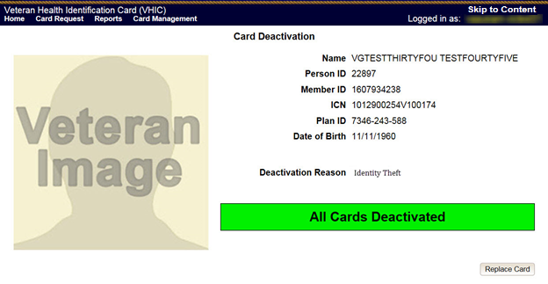

Figure 6‑47: All Cards Deactivated - Identity Theft

### Verifying Card Deactivation

The VHIC Administrator can verify that all of the cards for that Veteran have been deactivated by looking at the Card History report. To see all of the cards for a Veteran, search by using the Veteran’s Person ID, which was displayed on the last step of the card deactivation process.

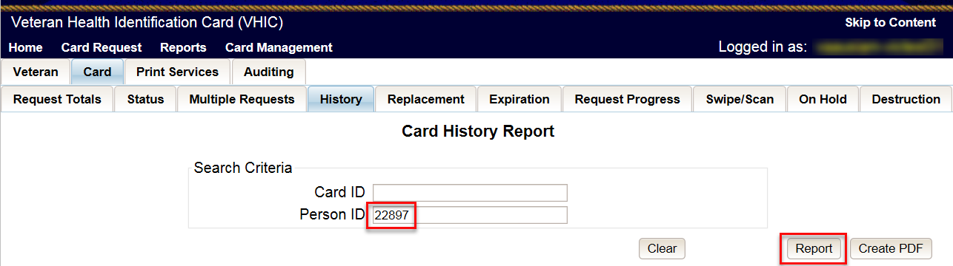

Figure 6‑48: Card History Report Query Screen

When looking at the Card History report, the user will see that the *Current Card Status* has been updated to *Deactivated* and the *Current MVI Status* has been updated to *Unlinked*.

The user will also see the messages for *Deactivated* and *MVI Correlation Unlinked* in the Message history section.

The Deactivation Reason field will also be populated with the deactivation reason that was selected during the card deactivation process.

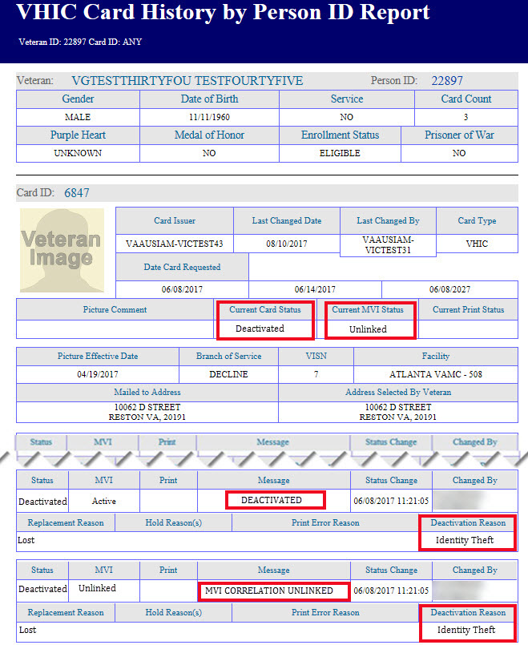

Figure 6‑49: Identity Theft

## Lost

### Accessing Card Deactivation

When the VHIC Administrator logs in to the VHIC application, they are presented with three menu options: Card Request, Reports, and Card Management. The Administrator can click either on the links in the header at the top of the screen or on the icon buttons in the middle of the screen.

To begin the Card Management process, the VHIC Administrator would click on either the Card Management link or the Card Management icon button.



Figure 6‑50: VHIC Administrator Home screen; click Card Management

### Step 1: Enter Search Terms

The first step in the process is to find the Veteran in the system. This is accomplished by entering enough search criteria to trigger a match within Master Veteran Index (MVI). The top of the screen offers guidance regarding the set of traits recommended to ensure the best match is found. These are guidelines and not necessarily the required set of traits that must be entered.

However, for optimal search results, copy the Veteran’s ICN from Toolkit and paste it into the ICN field on this screen.

Other search methods include:

* The Member ID from the front of the Veteran’s VHIC
* Last Name, First Name, DOB and SSN

***NOTE:*** *If using LN/FN/DOB/SSN combination, at a minimum, supply the Veteran's Last Name, plus values from at least two of the other three sections (Person, Address, and Identification).*

The more traits entered, the more likely a match will be returned. Additional guidance is also available on-screen by clicking on the blue circle containing a question mark.



Figure 6‑51: Help icon

This type of help is available throughout the application and will provide additional detail or clarification for that particular step or section.

Once the information has been entered into the required fields, click on **[Search]** to proceed to the next step.

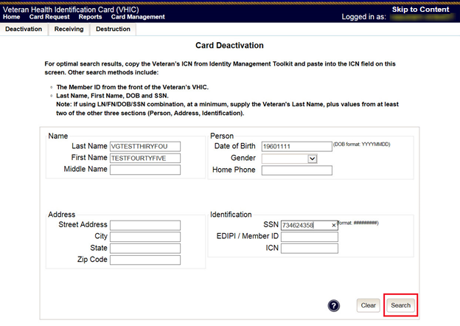

Figure 6‑52: Card Deactivation Enter Search Terms screen

### Step 2: Select Veteran

If the search was successful and a possible match has been found, the results of that search will be displayed on screen. From the list provided (up to 10 matches may be returned), select the appropriate Veteran by clicking on the **Veteran’s name** which is hyperlinked.

If the correct Veteran is not in the list, click the **[Back]** button and verify the traits entered are correct. If the traits are correct, try adding additional information to aid in triggering a match.

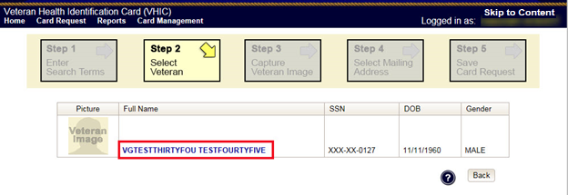

Figure 6‑53: Card Deactivation Select Veteran screen

### Select Deactivation Reason

Once the Administrator has selected the correct Veteran, the next step in the process is to select the reason for deactivating all the VHIC cards for this Veteran. Choose from one of the several deactivation reasons VHIC provides.

Select the *Lost* as thereason for deactivating the VHIC cards for this Veteran from the drop down menu.

Click on the **[Deactivate]** button to continue to the next step.

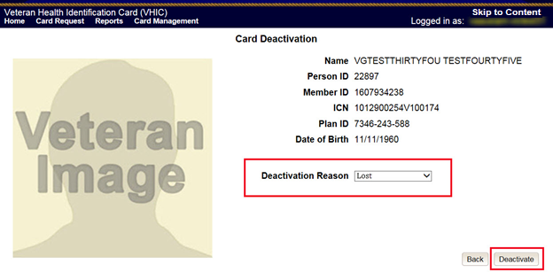

Figure 6‑54: Select Deactivation Reason screen

### Confirm Deactivation Request

The VHIC application will ask the user to confirm that they really want to deactivate all of the cards for this Veteran.

Click the **[OK]** button on the pop up window to continue.

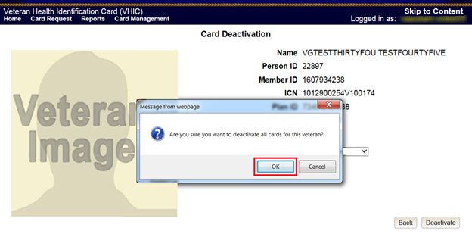

Figure 6‑55: Confirm Deactivation pop-up window

This screen shows that the Card Deactivation was completed successfully.

The selected deactivation reason will be displayed on this screen.

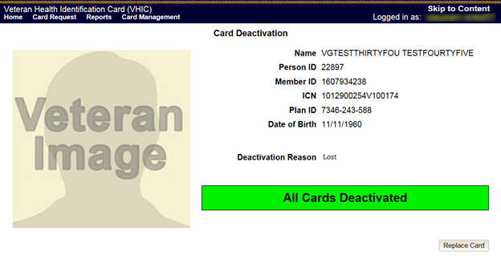

Figure 6‑56: All Cards Deactivated - Lost

### Request a Replacement Card

The VHIC Administrator will have the option to request a replacement card at the end of the Card Management process in select instances. Since *Lost* was the deactivation reason selected, the VHIC Admin is presented with the option to request a new card for the Veteran.

To request a replacement card, click the **[Replace a Card]** button.

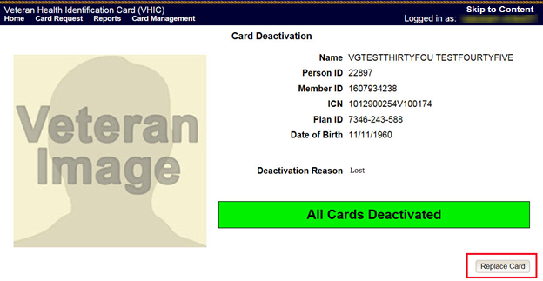

Figure 6‑57: Replace Card

This will take the user to *Step 3: Capture Veteran Image* of the card request process.

Click **[Next]** to reuse the existing photo for this Veteran. Then complete the card request process following the current procedures.

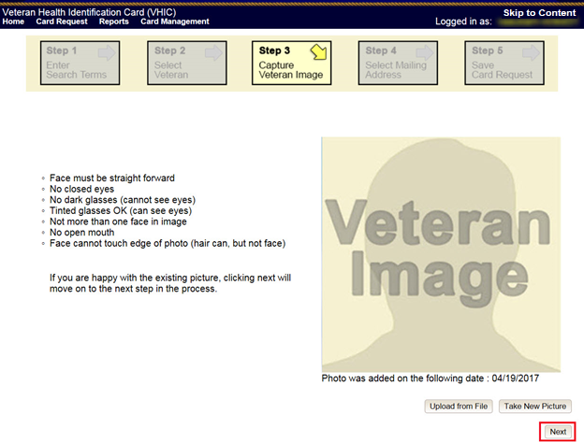

Figure 6‑58: Step 3 Capture Veteran Image screen

### Verifying Card Deactivation

The VHIC Administrator can verify that all of the cards for that Veteran have been deactivated by looking at the Card History report. To see all of the cards for a Veteran, search by using the Veteran’s Person ID, which was displayed on the last step of the card deactivation process.



Figure 6‑59: Card History Report Query Screen

When looking at the Card History report, the user will see that the *Current Card Status* has been updated to *Deactivated* and the *Current MVI Status* has been updated to *Unlinked*.

The user will also see the messages for *Deactivated* and *MVI Correlation Unlinked* in the Message history section.

The Deactivation Reason field will also be populated with the deactivation reason that was selected during the card deactivation process.

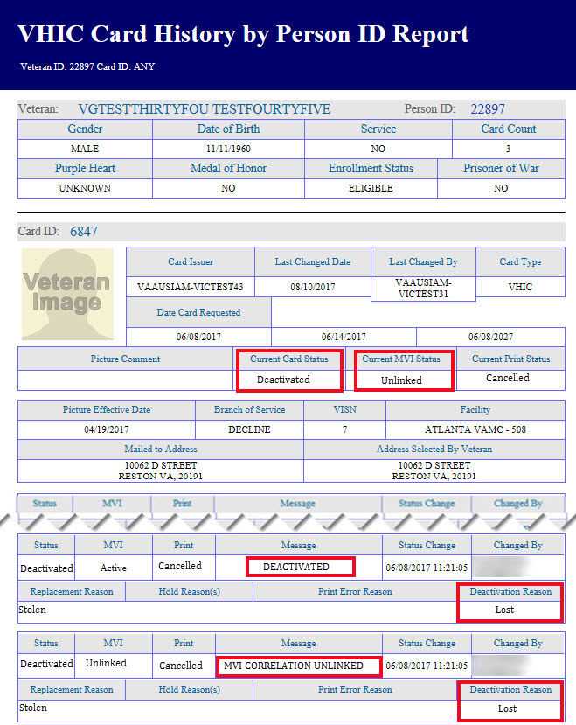

Figure 6‑60: Card History Report - Lost

## Other

### Accessing Card Deactivation

When the VHIC Administrator logs in to the VHIC application, they are presented with three menu options: Card Request, Reports, and Card Management. The Administrator can click either on the links in the header at the top of the screen or on the icon buttons in the middle of the screen.

To begin the Card Management process, the VHIC Administrator would click on either the Card Management link or the Card Management icon button.



Figure 6‑61: VHIC Administrator Home screen; click Card Management

### Step 1: Enter Search Terms

The first step in the process is to find the Veteran in the system. This is accomplished by entering enough search criteria to trigger a match within Master Veteran Index (MVI). The top of the screen offers guidance regarding the set of traits recommended to ensure the best match is found. These are guidelines and not necessarily the required set of traits that must be entered.

However, for optimal search results, copy the Veteran’s ICN from Toolkit and paste it into the ICN field on this screen.

Other search methods include:

* The Member ID from the front of the Veteran’s VHIC
* Last Name, First Name, DOB and SSN

***NOTE:*** *If using LN/FN/DOB/SSN combination, at a minimum, supply the Veteran's Last Name, plus values from at least two of the other three sections (Person, Address, and Identification).*

The more traits entered, the more likely a match will be returned. Additional guidance is also available on-screen by clicking on the blue circle containing a question mark.



Figure 6‑62: Help icon

This type of help is available throughout the application and will provide additional detail or clarification for that particular step or section.

Once the information has been entered into the required fields, click on **[Search]** to proceed to the next step.

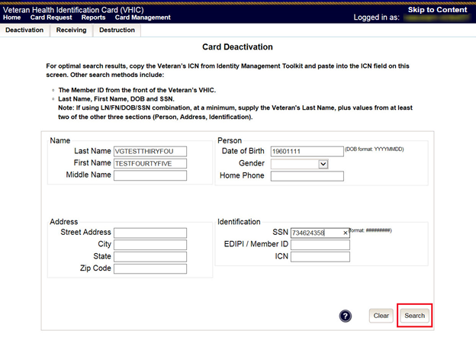

Figure 6‑63: Card Deactivation Enter Search Terms screen

### Step 2: Select Veteran

If the search was successful and a possible match has been found, the results of that search will be displayed on screen. From the list provided (up to 10 matches may be returned), select the appropriate Veteran by clicking on the **Veteran’s name** which is hyperlinked.

If the correct Veteran is not in the list, click the **[Back]** button and verify the traits entered are correct. If the traits are correct, try adding additional information to aid in triggering a match.

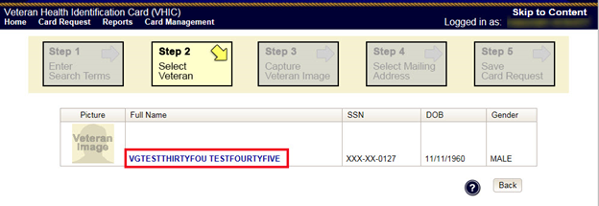

Figure 6‑64: Card Deactivation Select Veteran screen

### Select Deactivation Reason

Once the Administrator has selected the correct Veteran, the next step in the process is to select the reason for deactivating all the VHIC cards for this Veteran. Choose from one of the several deactivation reasons VHIC provides.

Select *Other* as the reason for deactivating the VHIC cards for this Veteran from the drop down menu and enter the details as to why the cards for this Veteran need deactivated using up to 50 characters.

Click on the **[Deactivate]** button to continue to the next step.

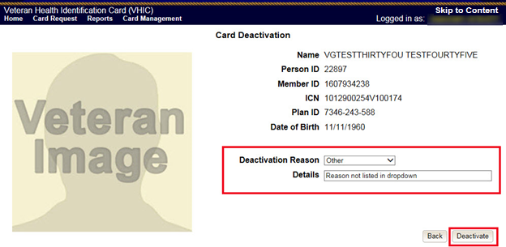

Figure 6‑65: Select Deactivation Reason screen

### Confirm Deactivation Request

The VHIC application will ask the user to confirm that they really want to deactivate all of the cards for this Veteran.

Click the **[OK]** button on the pop up window to continue.

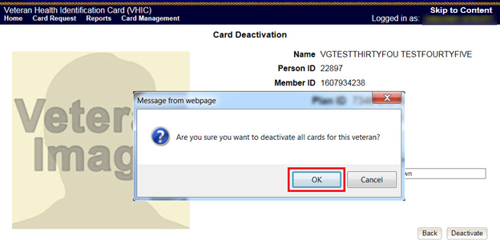

Figure 6‑66: Confirm Deactivation pop-up window

This screen shows that the Card Deactivation was completed successfully.

The selected deactivation reason will be displayed on this screen.

Since *Other* was the deactivation reason selected, the VHIC Admin is not presented with the option to request a new card for the Veteran.

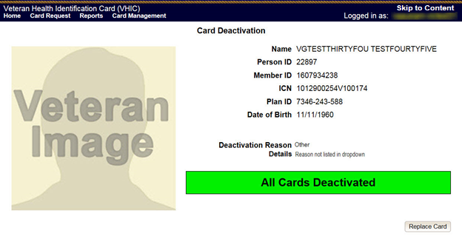

Figure 6‑67: All Cards Deactivated - Other

### Verifying Card Deactivation

The VHIC Administrator can verify that all of the cards for that Veteran have been deactivated by looking at the Card History report. To see all of the cards for a Veteran, search by using the Veteran’s Person ID, which was displayed on the last step of the card deactivation process.

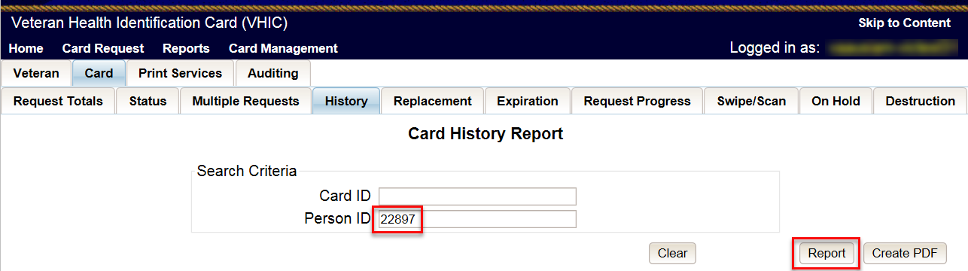

Figure 6‑68: Card History Report Query Screen

When looking at the Card History report, the user will see that the *Current Card Status* has been updated to *Deactivated* and the *Current MVI Status* has been updated to *Unlinked*.

The user will also see the messages for *Deactivated* and *MVI Correlation Unlinked* in the Message history section.

The Deactivation Reason field will also be populated with the deactivation reason that was selected during the card deactivation process.

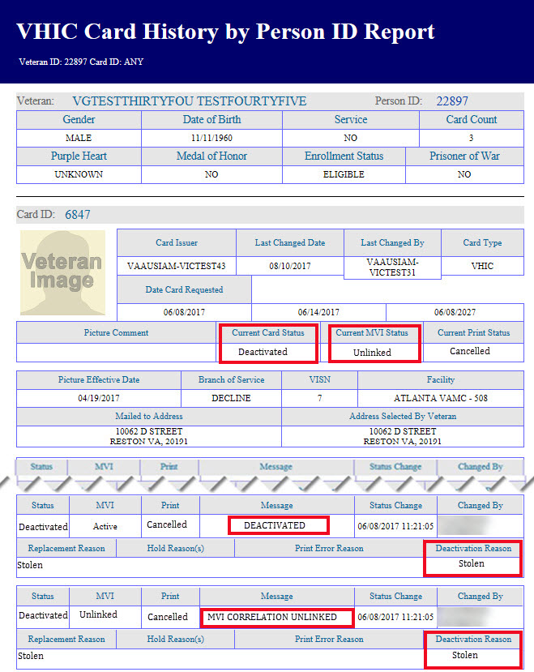

Figure 6‑69: Card History Report - Other

## Stolen

### Accessing Card Deactivation

When the VHIC Administrator logs in to the VHIC application, they are presented with three menu options: Card Request, Reports, and Card Management. The Administrator can click either on the links in the header at the top of the screen or on the icon buttons in the middle of the screen.

To begin the Card Management process, the VHIC Administrator would click on either the Card Management link or the Card Management icon button.



Figure 6‑70: VHIC Administrator Home screen; click Card Deactivation

### Step 1: Enter Search Terms

The first step in the process is to find the Veteran in the system. This is accomplished by entering enough search criteria to trigger a match within Master Veteran Index (MVI). The top of the screen offers guidance regarding the set of traits recommended to ensure the best match is found. These are guidelines and not necessarily the required set of traits that must be entered.

However, for optimal search results, copy the Veteran’s ICN from Toolkit and paste it into the ICN field on this screen.

Other search methods include:

* The Member ID from the front of the Veteran’s VHIC
* Last Name, First Name, DOB and SSN

***NOTE:*** *If using LN/FN/DOB/SSN combination, at a minimum, supply the Veteran's Last Name, plus values from at least two of the other three sections (Person, Address, and Identification).*

The more traits entered, the more likely a match will be returned. Additional guidance is also available on-screen by clicking on the blue circle containing a question mark.



Figure 6‑71: Help icon

This type of help is available throughout the application and will provide additional detail or clarification for that particular step or section.

Once the information has been entered into the required fields, click on **[Search]** to proceed to the next step.

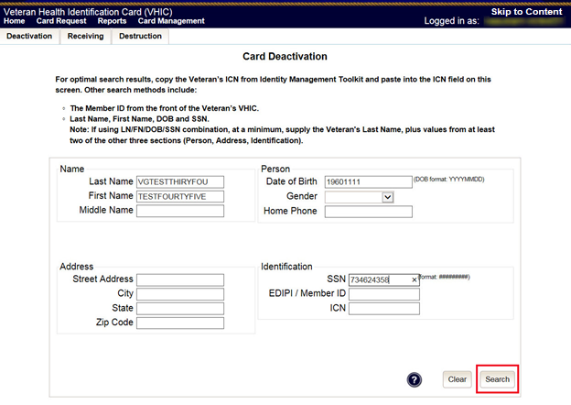

Figure 6‑72: Card Deactivation Enter Search Terms screen

### Step 2: Select Veteran

If the search was successful and a possible match has been found, the results of that search will be displayed on screen. From the list provided (up to 10 matches may be returned), select the appropriate Veteran by clicking on the **Veteran’s name** which is hyperlinked.

If the correct Veteran is not in the list, click the **[Back]** button and verify the traits entered are correct. If the traits are correct, try adding additional information to aid in triggering a match.

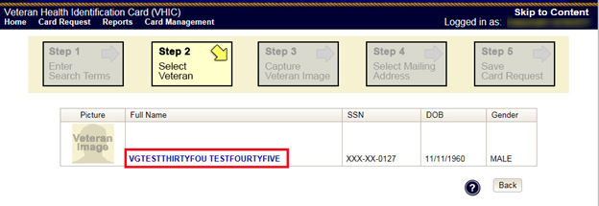

Figure 6‑73: Card Deactivation Select Veteran screen

### Select Deactivation Reason

Once the Administrator has selected the correct Veteran, the next step in the process is to select the reason for deactivating all the VHIC cards for this Veteran. Choose from one of the several deactivation reasons VHIC provides.

Select *Stolen* as thereason for deactivating the VHIC cards for this Veteran from the drop down menu.

Click on the **[Deactivate]** button to continue to the next step.

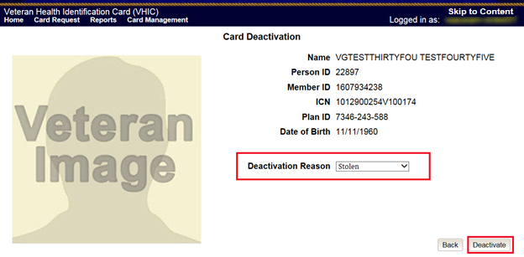

Figure 6‑74: Select Deactivation Reason screen

### Confirm Deactivation Request

The VHIC application will ask the user to confirm that they really want to deactivate all of the cards for this Veteran.

Click the **[OK]** button on the pop up window to continue.

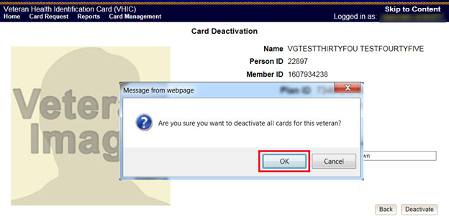

Figure 6‑75: Confirm Deactivation pop-up window

This screen shows that the Card Management was completed successfully.

The selected deactivation reason will be displayed on this screen.

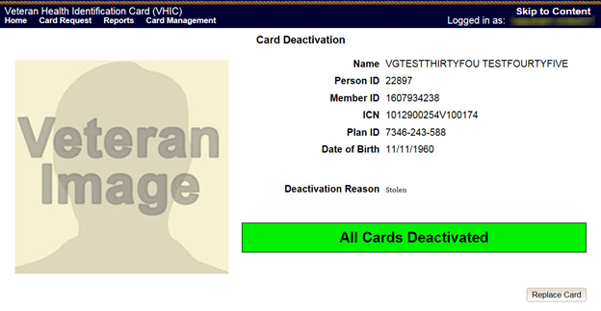

Figure 6‑76: All Cards Deactivated - Stolen

### Request a Replacement Card

The VHIC Administrator will have the option to request a replacement card at the end of the card deactivation process in select instances. Since *Stolen* was the deactivation reason selected, the VHIC Admin is presented with the option to request a new card for the Veteran.

To request a replacement card, click the **[Replace a Card]** button.

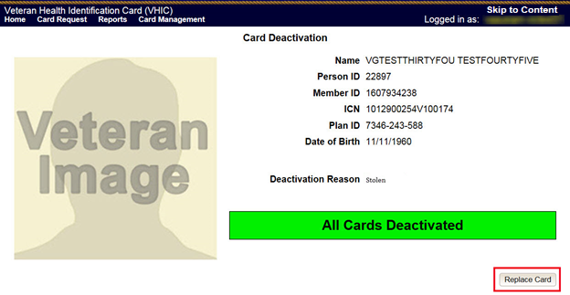

Figure 6‑77: Replace Card

This will take the user to *Step 3: Capture Veteran Image* of the card request process.

Click **[Next]** to reuse the existing photo for this Veteran. Then complete the card request process following the current procedures.

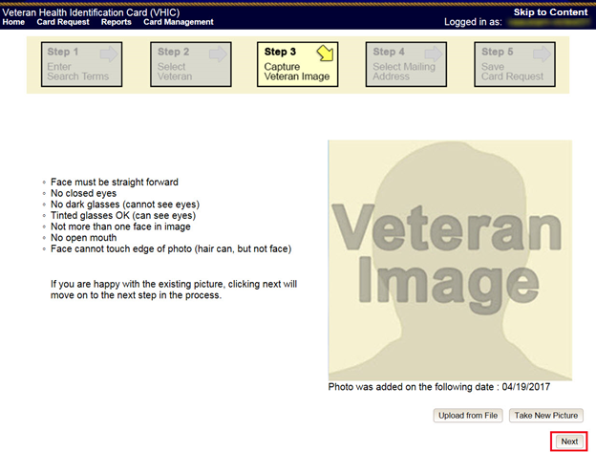

Figure 6‑78: Step 3 Capture Veteran Image screen

### Verifying Card Deactivation

The VHIC Administrator can verify that all of the cards for that Veteran have been deactivated by looking at the Card History report. To see all of the cards for a Veteran, search by using the Veteran’s Person ID, which was displayed on the last step of the card deactivation process.



Figure 6‑79: Card History Report Query Screen

When looking at the Card History report, the user will see that the *Current Card Status* has been updated to *Deactivated* and the *Current MVI Status* has been updated to *Unlinked*.

The user will also see the messages for *Deactivated* and *MVI Correlation Unlinked* in the Message history section.

The Deactivation Reason field will also be populated with the deactivation reason that was selected during the card deactivation process.



Figure 6‑80: Card History Report - Stolen

# Card Receiving

Table 4: Who can receive a card?

| At a Glance… |  |
| --- | --- |
| Who can receive a card? | *Administrator, Tech Admin (Tier 3)* |

Per SOP, the proper disposal of undelivered Veteran Health Identification Cards (VHICs) , Veteran Identification Cards (VICs), Personal Identity Verification (PIV) cards, and other personal items that are returned to the Health Eligibility Center (HEC) require both receiving and destructions logs which will be maintained for six years from the date of document creation, or last effective date, whichever is later.

This section will walk the VHIC Administrator through the process of logging VHIC cards received at the HEC.

## Cards Received

### Accessing Cards Received Screen

When the VHIC Administrator logs in to the VHIC application, they are presented with three menu options: Card Request, Reports, and Card Management. The Administrator can click either on the links in the header at the top of the screen or on the icon buttons in the middle of the screen.

To begin the Card Management process, the VHIC Administrator would click on either the Card Management link or the Card Management icon button.



Figure 7‑1: VHIC Administrator Home screen; click Card Management

The Card Management button will automatically take you to the Card Deactivation Tab. You will need to select Card Receiving by clicking on the Receiving Tab at the top of the page.

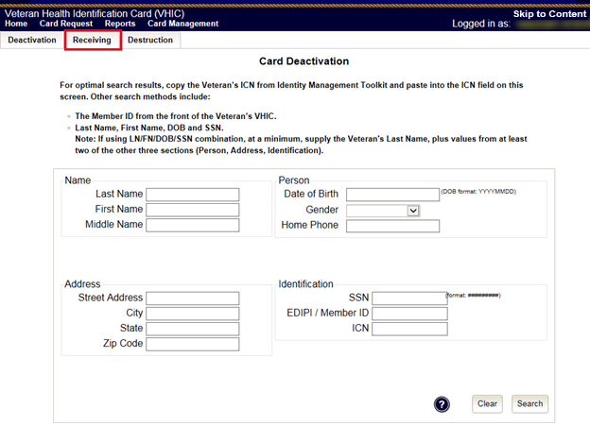

Figure 7‑2: Select Card Receiving Tab

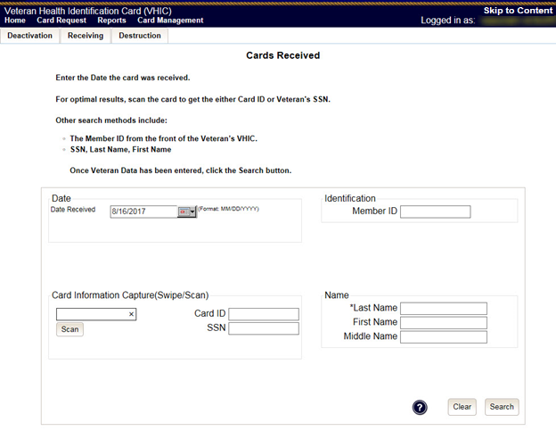

Figure 7‑3: Card Received Screen

### Step 1: Enter Search Terms

The first step in the process is to find the VHIC Card in the system. For optimal results, this is accomplished by scanning the barcode into the system. Once the barcode is captured, click the Scan button, and the Card ID will populate.

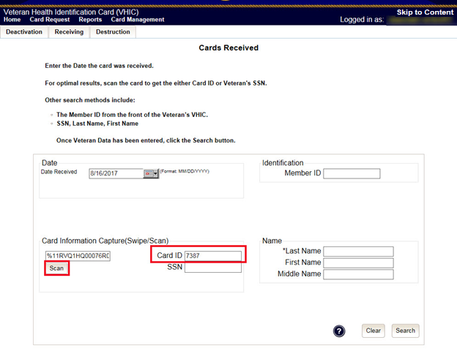

Figure 7‑4: Card Scanned into system, Card ID populates

Other search methods include:

* The Member ID from the front of the Veteran’s VHIC
* Last Name, First Name, DOB and SSN

***NOTE:*** *If using LN/FN/DOB/SSN combination, at a minimum, supply the Veteran's Last Name, plus values from at least two of the other three sections (Person, Address, and Identification).*

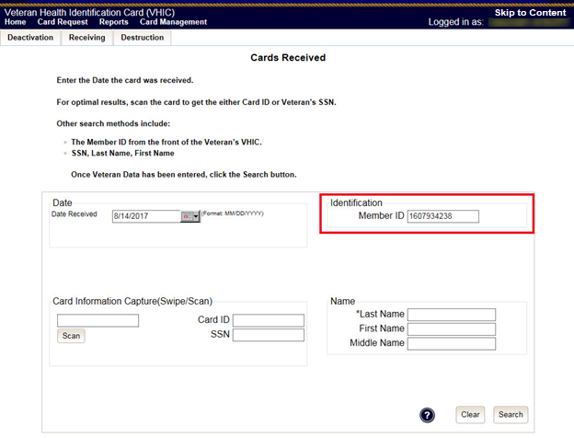

Figure 7‑5: Search by Member ID

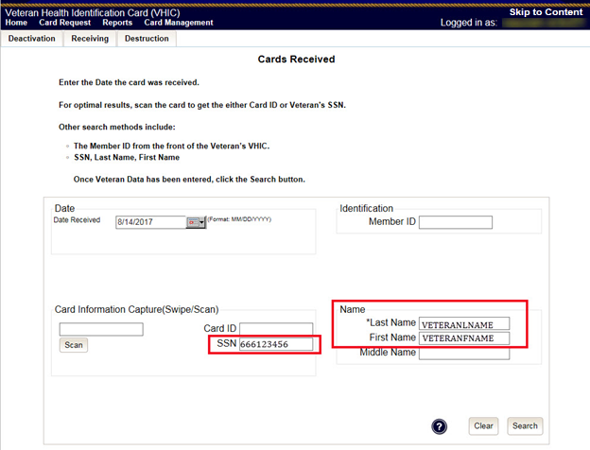

Figure 7‑6: Search by Veteran Name/SSN

Additional guidance is also available on-screen by clicking on the blue circle containing a question mark.



Figure 7‑7: Help icon

This type of help is available throughout the application and will provide additional detail or clarification for that particular step or section.

Once the information has been entered into the required fields, click on **[Search]** to proceed to the next step.

### Step 2: Card Verification

After search is completed, the system will display the details of the VHIC card scanned. Verify that all information displayed is correct prior to clicking submit.

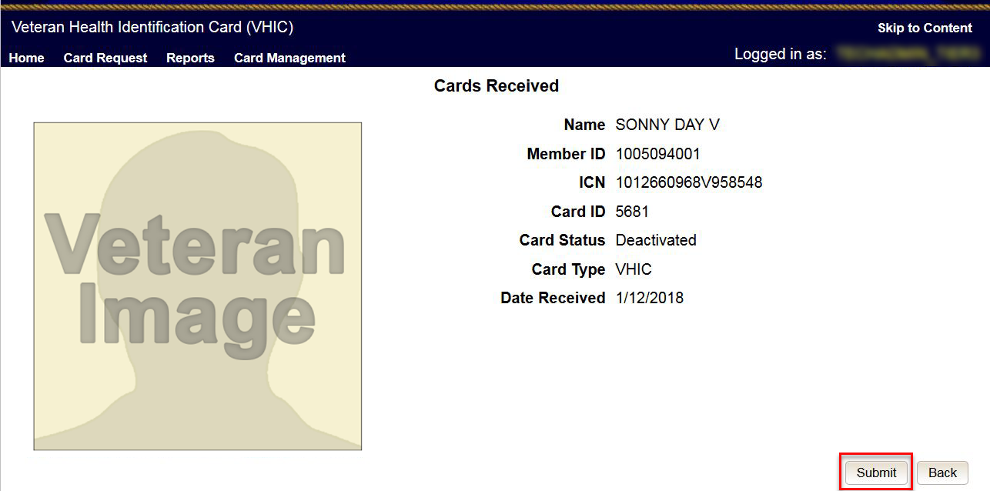

Figure 7‑8: VHIC Card details displayed

Submitting the card information will update the status of the VHIC card and log it into the system as having been received.

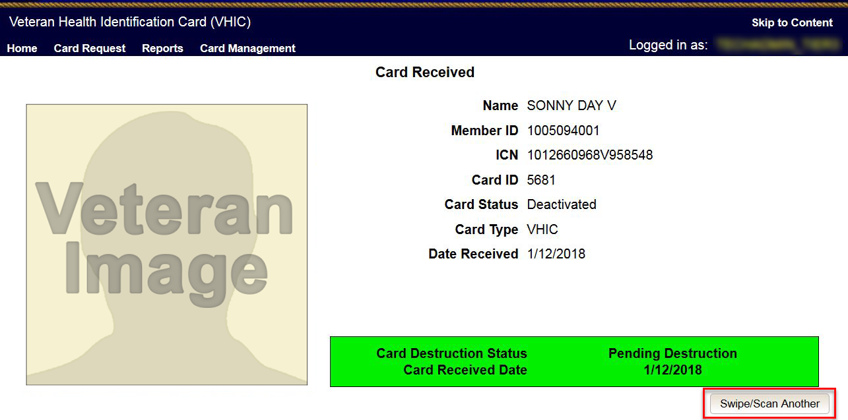

Figure 7‑9: Card status updated - Pending Destruction

Selecting the Swipe/Scan Another button at the bottom of the screen will bring you back to the Receiving search page.

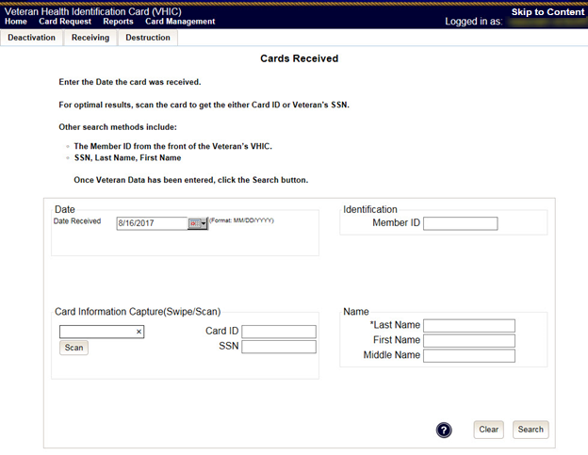

Figure 7‑10: Receiving Search Page

# Card Destruction

Table 5. Who can destroy a card?

| At a Glance… |  |
| --- | --- |
| Who can destroy a card? | *Administrator, Tech Admin (Tier 3)* |

Per SOP, the proper disposal of undelivered Veteran Health Identification Cards (VHICs) , Veteran Identification Cards (VICs), Personal Identity Verification (PIV) cards, and other personal items that are returned to the Health Eligibility Center (HEC) require both receiving and destructions logs which will be maintained for six years from the date of document creation, or last effective date, whichever is later.

This section will walk the VHIC Administrator through the process of destroying VHIC cards received at the HEC. The system will track all VHIC cards received and destroyed, and the logs can be viewed by running the appropriate reports.

## Card Destruction

### Accessing Card Destruction Screen

When the VHIC Administrator logs in to the VHIC application, they are presented with three menu options: Card Request, Reports, and Card Management. The Administrator can click either on the links in the header at the top of the screen or on the icon buttons in the middle of the screen.

To begin the Card Management process, the VHIC Administrator would click on either the Card Management link or the Card Management icon button.

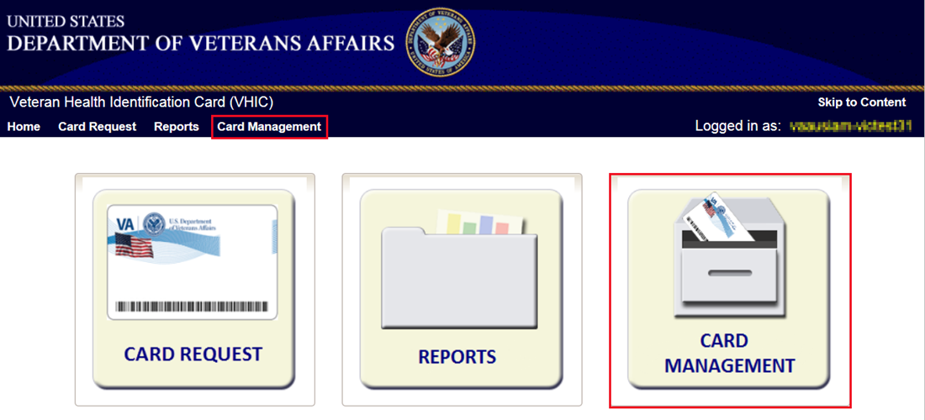

Figure 8‑1: VHIC Administrator Home screen; click Card Management

The Card Management button will automatically take you to the Card Deactivation Tab. You will need to select Card Destruction by clicking on the Destruction Tab at the top of the page.

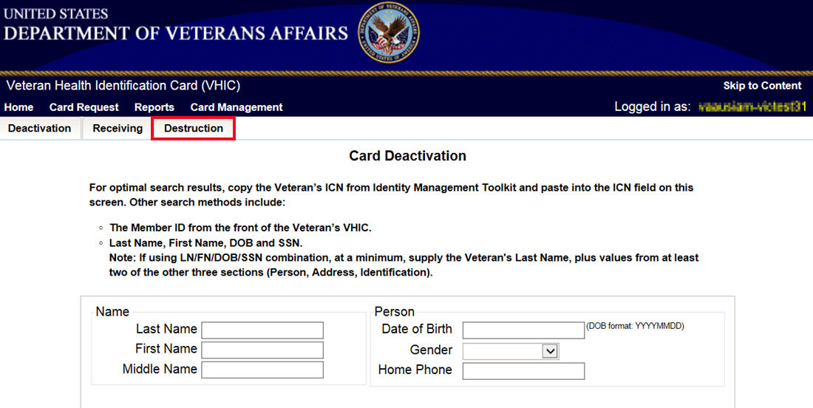

Figure 8‑2: Select Card Destruction Tab

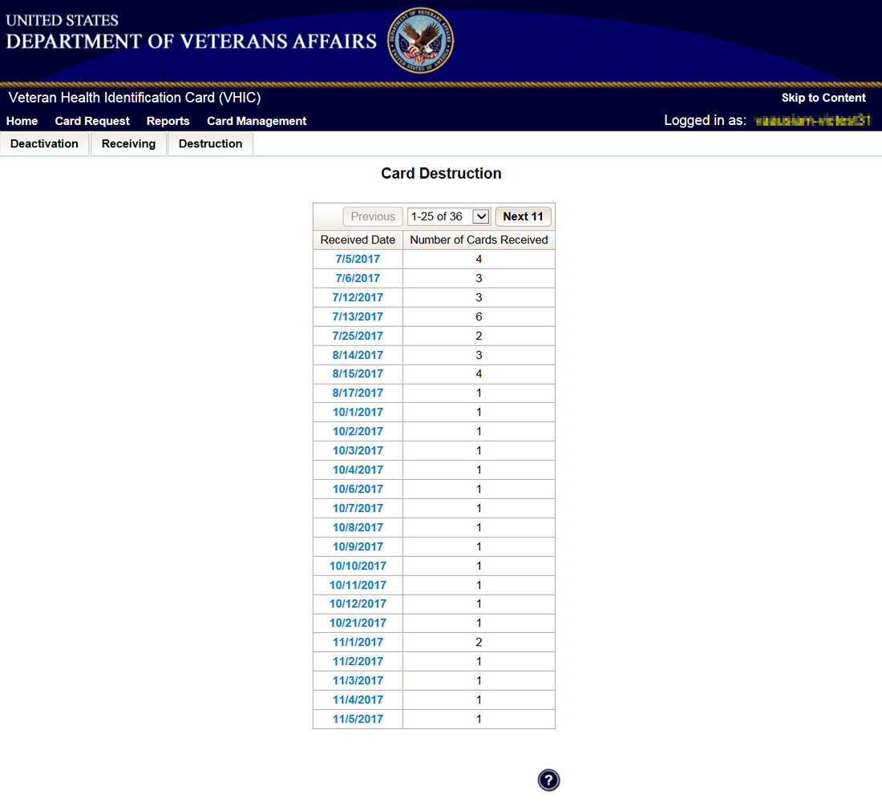

Figure 8‑3: Card Destruction Screen

### Step 1: Select Cards for Destruction

The Card Destruction screen shows a table of cards received, logged, and ready for destruction. The table indicates the Received Date and Number of Cards Received, allowing for batch destruction as needed. **Note**: *To view details of cards received, you will need to run the Card Destruction Report see* ***Veteran Health Identification Card (VHIC 4.8) User Guide - Volume 2 – Reports.***Select cards for destruction by clicking on the appropriate link found under Received Date.

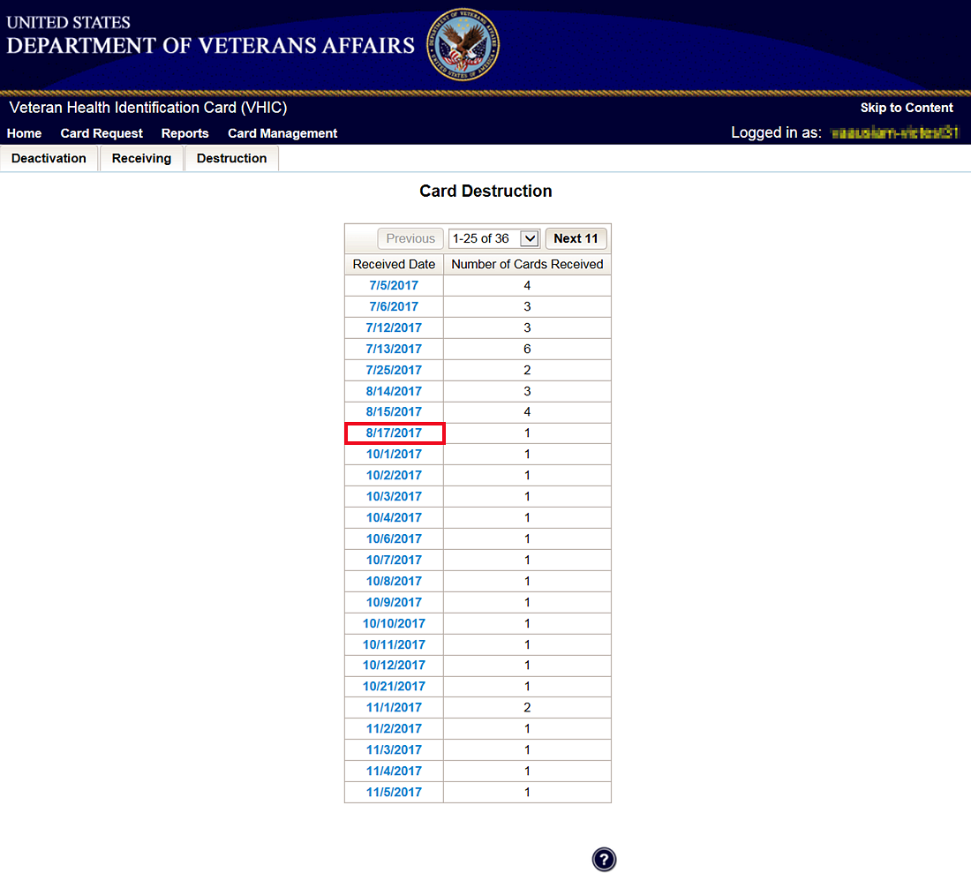

Figure 8‑4: Select Cards by Received Date for Destruction

### Select Date of Destruction

Once the Received Date has been selected, you will be directed to a new screen for entering the date of destruction. The Date Destroyed will be populated with the current date by default. To provide a different date, you may enter it manually, or select it from the calendar dropdown. You will then click the Submit button.

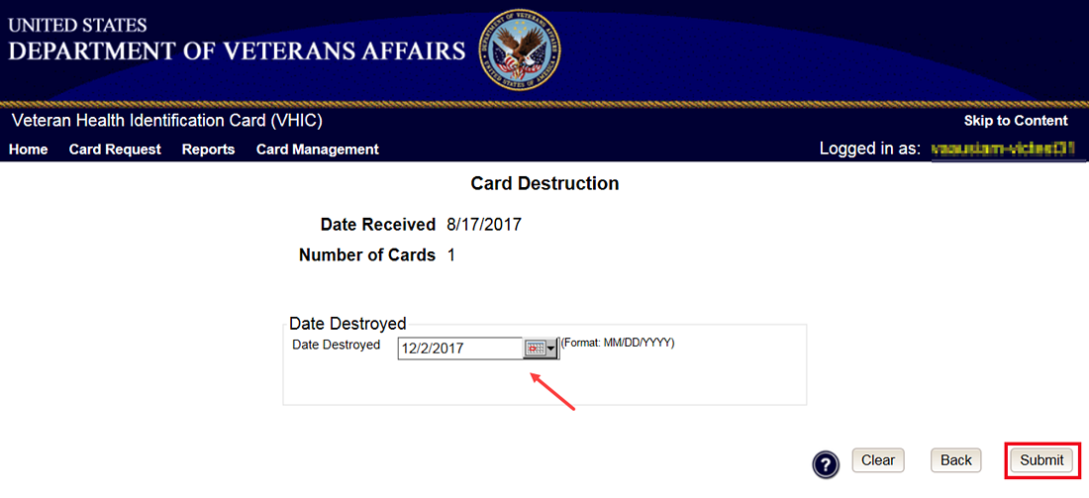

Figure 8‑5: Select Date of Destruction

After Clicking submit, a pop up message will appear to confirm destruction of the selected cards.

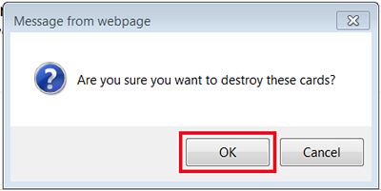

Figure 8‑6: Card Destruction Confirmation Message

### Card Destruction Status Displayed

Submitting the Card Destruction Date will update the status of the VHIC card(s) and log it into the system as having been destroyed. You will have the options of either exiting the Status Screen , or clicking the Destroy Another button to return to the main Card Destruction screen.

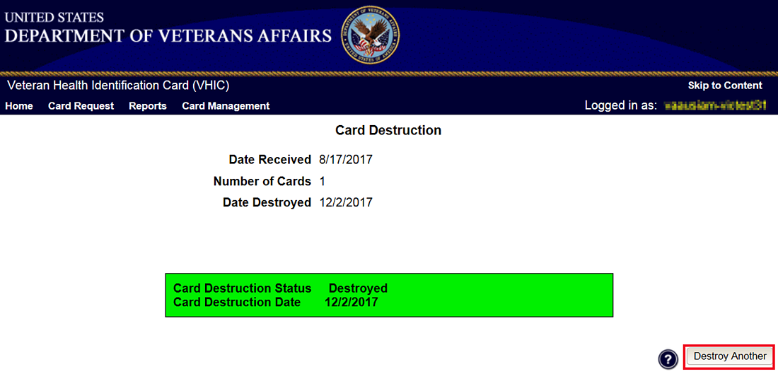

Figure 8‑7: Card Destruction Status

# Reports

A comprehensive walkthrough of all of the different reports that are available to VHIC users and the types of metrics that can be obtained, as well as an explanation of the user role permissions for accessing the reports are included in the **Veteran Health Identity Card (VHIC 4.8) User Guide - Volume 2 - Reports** document.

# Troubleshooting

For a through set of troubleshooting guidelines, please refer to the **Veteran Health Identification Card (VHIC 4.8) User Guide - Volume 4 - Troubleshooting** document.

# Appendix A: VHIC Roles

|  |  |  |  |  |  |  |  |  |  |  |  |  |  |
| --- | --- | --- | --- | --- | --- | --- | --- | --- | --- | --- | --- | --- | --- |
|  | | |  | |  | VHIC Role | | | | | | | |
| Function/Report Title | | | Navigation | | Selected Status from Drop Down Menu | Administrator | Technical Administrator Tier 3 | Supervisor | | Associate | | Auditor | Read-Only User |
| **CARD REQUESTS** | | | | | | | | | | | | | |
| Request Cards | | | (**Card Requests** icon on Home Screen/ **Card Requests** link in top Navigation Bar) | | N/A | X | X | X | | X | |  |  |
| Deactivate Cards | | | (**Card Management** icon on Home Screen/ **Card Management** link in top Navigation Bar) | | N/A | X | X |  | |  | |  |  |
| **REPORTS** | | | | | | | | | | | | | |
| **Veteran** (Direct Search) | | | (**Reports** icon on Home Screen/ **Reports** link in top Navigation Bar) | |  | | | | | | | | |
| Basic (*no national option*) | | | | | | | | | | | | | |
| Veteran Detail Report | | | Default view for Reports | | N/A | X | X | | X | | X | X | X |
| **Card Request Totals** | | | (**Card** menu tab - **Request Totals** sub-menu tab) | |  | | | | | | | | |
| *National* | | | | | | | | | | | | | |
| VHIC Card Request Totals | | | Click National Checkbox | | N/A | X | X | |  | |  | X |  |
| *VISN* | | | | | | | | | | | | | |
| VHIC Card Request Totals | | | Click VISN radio button | | N/A | X | X | |  | |  | X | X |
| *Facility* | | | | | | | | | | | | | |
| VHIC Card Request Totals | | | Click Facility ration button | | N/A | X | X | | X | | X | X | X |
| **Card Status - MVI Status Report** | | | (**Card** menu tab - **Status** sub-menu tab - **MVI Status** radio button) | |  | | | | | | | | |
| *National* | | | | | | | | | | | | | |
| VHIC MVI Status National Report | | | Click National Checkbox | | Active | X | X | |  | |  | X |  |
|  | | |  | | Not Correlated | X | X | |  | |  | X |  |
|  | | |  | | Rejected | X | X | |  | |  | X |  |
|  | | |  | | Unlinked | X | X | |  | |  | X |  |
| *VISN* | | | | | | | | | | | | | |
| VHIC MVI Status Summary Report | | | Click VISN radio button | | Active | X | X | |  | |  | X |  |
|  | | |  | | Not Correlated | X | X | |  | |  | X |  |
|  | | |  | | Rejected | X | X | |  | |  | X |  |
|  | | |  | | Unlinked | X | X | |  | |  | X |  |
| *Facility* | | | | | | | | | | | | | |
| VHIC MVI Status Summary Report | | | Click Facility ration button | | Active | X | X | | X | | X | X |  |
|  | | |  | | Not Correlated | X | X | | X | | X | X |  |
|  | | |  | | Rejected | X | X | | X | | X | X |  |
|  | | |  | | Unlinked | X | X | | X | | X | X |  |
| *Facility Detail* | | | | | | | | | | | | | |
| VHIC MVI Status Detail Report | | | Click on the Facility Number | | Active | X | X | | X | | X | X |  |
|  | | |  | | Not Correlated | X | X | | X | | X | X |  |
|  | | |  | | Rejected | X | X | | X | | X | X |  |
|  | | |  | | Unlinked | X | X | | X | | X | X |  |
|  | | |  | |  |  |  | |  | |  |  |  |
| **Card Status - Card Status Report** | | | (**Card** menu tab - **Status** sub-menu tab - **Card Status** radio button) | |  | | | | | | | | |
| *National* | | | | | | | | | | | | | |
| VHIC Card Status National Report | | | Click National Checkbox | | Replaced | X | X | |  | |  | X |  |
|  | | |  | | Deactivated | X | X | |  | |  | X |  |
|  | | |  | | Expired | X | X | |  | |  | X |  |
|  | | |  | | On Hold | X | X | |  | |  | X |  |
|  | | |  | | Pending | X | X | |  | |  | X |  |
|  | | |  | | Requested | X | X | |  | |  | X |  |
|  | | |  | | Defunct | X | X | |  | |  | X |  |
|  | | |  | | Pending Destruction | X | X | |  | |  | X |  |
|  | | |  | | Destroyed | X | X | |  | |  | X |  |
| *VISN* | | | | | | | | | | | | | |
| VHIC Card Status Summary Report | | | Click VISN radio button | | Replaced | X | X | |  | |  | X |  |
|  | | |  | | Deactivated | X | X | |  | |  | X |  |
|  | | |  | | Expired | X | X | |  | |  | X |  |
|  | | |  | | On Hold | X | X | |  | |  | X |  |
|  | | |  | | Pending | X | X | |  | |  | X |  |
|  | | |  | | Requested | X | X | |  | |  | X |  |
|  | | |  | | Defunct | X | X | |  | |  | X |  |
|  | | |  | | Pending Destruction | X | X | |  | |  | X |  |
|  | | |  | | Destroyed | X | X | |  | |  | X |  |
| *Facility* | | | | | | | | | | | | | |
| VHIC Card Status Summary Report | | | Click Facility ration button | | Replaced | X | X | | X | | X | X |  |
|  | | |  | | Deactivated | X | X | | X | | X | X |  |
|  | | |  | | Expired | X | X | | X | | X | X |  |
|  | | |  | | On Hold | X | X | | X | | X | X |  |
|  | | |  | | Pending | X | X | | X | | X | X |  |
|  | | |  | | Requested | X | X | | X | | X | X |  |
|  | | |  | | Defunct | X | X | | X | | X | X |  |
|  | | |  | | Pending Destruction | X | X | | X | | X | X |  |
|  | | |  | | Destroyed | X | X | | X | | X | X |  |
| *Facility Detail* | | | | | | | | | | | | | |
| VHIC Card Status Detail Report | | | Click on the Facility Number | | Replaced | X | X | | X | | X | X |  |
|  | | |  | | Deactivated | X | X | | X | | X | X |  |
|  | | |  | | Expired | X | X | | X | | X | X |  |
|  | | |  | | On Hold | X | X | | X | | X | X |  |
|  | | |  | | Pending | X | X | | X | | X | X |  |
|  | | |  | | Requested | X | X | | X | | X | X |  |
|  | | |  | | Defunct | X | X | | X | | X | X |  |
|  | | |  | | Pending Destruction | X | X | | X | | X | X |  |
|  | | |  | | Destroyed | X | X | | X | | X | X |  |
| **Card Status - Print Release Status Report** | | | (**Card** menu tab - **Status** sub-menu tab - **Print Status** radio button) | |  | | | | | | | | |
| *National* | | | | | | | | | | | | | |
| VHIC Print Status National Report | | | Click National Checkbox | | Cancelled | X | X | |  | |  | X |  |
|  | | |  | | Error | X | X | |  | |  | X |  |
|  | | |  | | Mailed | X | X | |  | |  | X |  |
|  | | |  | | Not Started | X | X | |  | |  | X |  |
|  | | |  | | Pending | X | X | |  | |  | X |  |
|  | | |  | | Received | X | X | |  | |  | X |  |
|  | | |  | | Rejected | X | X | |  | |  | X |  |
|  | | |  | | Sent | X | X | |  | |  | X |  |
| *VISN* | | | | | | | | | | | | | |
| VHIC Print Status Detail Report | | | Click VISN radio button | | Cancelled | X | X | |  | |  | X |  |
|  | | |  | | Error | X | X | |  | |  | X |  |
|  | | |  | | Mailed | X | X | |  | |  | X |  |
|  | | |  | | Not Started | X | X | |  | |  | X |  |
|  | | |  | | Pending | X | X | |  | |  | X |  |
|  | | |  | | Received | X | X | |  | |  | X |  |
|  | | |  | | Rejected | X | X | |  | |  | X |  |
|  | | |  | | Sent | X | X | |  | |  | X |  |
| *Facility* | | | | | | | | | | | | | |
| VHIC Print Status Detail Report | | | Click Facility ration button | | Cancelled | X | X | | X | | X | X |  |
|  | | |  | | Error | X | X | | X | | X | X |  |
|  | | |  | | Mailed | X | X | | X | | X | X |  |
|  | | |  | | Not Started | X | X | | X | | X | X |  |
|  | | |  | | Pending | X | X | | X | | X | X |  |
|  | | |  | | Received | X | X | | X | | X | X |  |
|  | | |  | | Rejected | X | X | | X | | X | X |  |
|  | | |  | | Sent | X | X | | X | | X | X |  |
| *Facility Detail* | | | | | | | | | | | | | |
| VHIC Print Status Detail Report | | | Click on the Facility Number | | Cancelled | X | X | | X | | X | X |  |
|  | | |  | | Error | X | X | | X | | X | X |  |
|  | | |  | | Mailed | X | X | | X | | X | X |  |
|  | | |  | | Not Started | X | X | | X | | X | X |  |
|  | | |  | | Pending | X | X | | X | | X | X |  |
|  | | |  | | Received | X | X | | X | | X | X |  |
|  | | |  | | Rejected | X | X | | X | | X | X |  |
|  | | |  | | Sent | X | X | | X | | X | X |  |
| **Card Request Progress** | | | (**Card** menu tab - **Request Progress** sub-menu tab) | |  | | | | | | | | |
| *National* | | | | | | | | | | | | | |
| VHIC Card Request Progress National Summary Report | | | Click National Checkbox | | N/A | X | X | |  | |  | X |  |
| *VISN* | | | | | | | | | | | | | |
| VHIC Card Request Progress VISN Summary Report | | | Click VISN radio button | | N/A | X | X | |  | |  | X |  |
| *Facility* | | | | | | | | | | | | | |
| VHIC Card Request Progress Facility Summary Report | | | Click Facility ration button | | N/A | X | X | | X | | X | X |  |
| *Facility Detail* | | | | | | | | | | | | | |
| VHIC Card Request Progress Facility Detail Report | | | Click on the Facility Number | | N/A | X | X | | X | | X | X |  |
| **Multiple Requests** | | | (**Card** menu tab - **Multiple Requests** sub-menu tab) | |  | | | | | | | | |
| **Cards Requested** |  | | (**Cards Requested** radio button) | |  |  |  | |  | |  |  |  |
| *National* | | | | | | | | | | | | | |
| VHIC Summary Report for Number of Cards Requested | | | Click National Checkbox | | N/A | X | X | |  | |  | X |  |
| *VISN* | | | | | | | | | | | | | |
| VHIC Summary Report for Number of Cards Requested | | | Click VISN radio button | | N/A | X | X | |  | |  | X |  |
| *Facility* | | | | | | | | | | | | | |
| VHIC Detailed Report for Number of Cards Requested | | | Click Facility ration button | | N/A | X | X | | X | | X | X |  |
| *Facility Detail* | | | | | | | | | | | | | |
| VHIC Facility Detail Report for Number of Cards Requested | | | Click on the Facility Number | | N/A | X | X | | X | | X | X |  |
| **Cards Mailed** |  | | (**Cards Mailed** radio button) | |  |  |  | |  | |  |  |  |
| *National* | | | | | | | | | | | | | |
| VHIC Summary Report for Number of Cards Requested | | | Click National Checkbox | | N/A | X | X | |  | |  | X |  |
| *VISN* | | | | | | | | | | | | | |
| VHIC Summary Report for Number of Cards Requested | | | Click VISN radio button | | N/A | X | X | |  | |  | X |  |
| *Facility* | | | | | | | | | | | | | |
| VHIC Detailed Report for Number of Cards Mailed | | | Click Facility ration button | | N/A | X | X | | X | | X | X |  |
| *Facility Detail* | | | | | | | | | | | | | |
| VHIC Facility Detail Report for Number of Cards Mailed | | | Click on the Facility Number | | N/A | X | X | | X | | X | X |  |
| **Card History** | | | (**Card** menu tab - **History** sub-menu tab) | |  | | | | | | | | |
| *Card ID* | | | | | | | | | | | | | |
| VHIC Card History | | | Enter Veteran's Card ID in the Card ID field | | N/A | X | X | | X | | X | X | X |
| *Person ID* | | | | | | | | | | | | | |
| VHIC Card History | | | Enter Veteran's Person ID in the Person ID field | | N/A | X | X | | X | | X | X | X |
| **Expiration** | | | (**Card** menu tab - **Expiration** sub-menu tab) | |  | | | | | | | | |
| *National* | | | | | | | | | | | | | |
| VHIC Card Expiration Summary Report | | | Click National Checkbox | | N/A | X | X | |  | |  | X |  |
| *VISN* | | | | | | | | | | | | | |
| VHIC Card Expiration Summary Report | | | Click VISN radio button | | N/A | X | X | |  | |  | X |  |
| *Facility* | | | | | | | | | | | | | |
| VHIC Card Expiration Site Report | | | Click Facility ration button | | N/A | X | X | | X | | X | X |  |
| *Facility Detail* | | | | | | | | | | | | | |
| VHIC Card Expiration Detail Report | | | Click on the Facility Number | | N/A | X | X | | X | | X | X |  |
| **Replacement** | | | (**Card** menu tab - **Replacement** sub-menu tab) | |  | | | | | | | | |
| *National* | | | | | | | | | | | | | |
| VHIC Card Replacement Summary Report | | | Click National Checkbox | | N/A | X | X | |  | |  | X |  |
| *VISN* | | | | | | | | | | | | | |
| VHIC Card Replacement Summary Report | | | Click VISN radio button | | N/A | X | X | |  | |  | X |  |
| *Facility* | | | | | | | | | | | | | |
| VHIC Card Replacement Facility Report | | | Click Facility ration button | | N/A | X | X | | X | | X | X |  |
| *Facility Sub-Reason Summary* | | | | | | | | | | | | | |
| VHIC Card Replacement Facility Subreason Report | | | Click # of Cards Replaced | | N/A | X | X | | X | | X | X |  |
| *Facility Sub-Reason Detail* | | | | | | | | | | | | | |
| VHIC Card Replacement Facility Subreason Detail | | | Click # of Cards Replaced | | N/A | X | X | | X | | X | X |  |
| **On Hold** | | | (**Card** menu tab - **On-Hold** sub-menu tab) | |  | | | | | | | | |
| *National* | | | | | | | | | | | | | |
| VHIC On Hold Card Status National Summary Report | | | Click National Checkbox | | Not Proofed | X | X | |  | |  | X |  |
|  | | |  | | Eligibility Pending | X | X | |  | |  | X |  |
|  | | |  | | Enrollment Services Unavailable | X | X | |  | |  | X |  |
|  | | |  | | Bad Data | X | X | |  | |  | X |  |
|  | | |  | | All | X | X | |  | |  | X |  |
| *VISN* | | | | | | | | | | | | | |
| VHIC On Hold Card Status VISN Summary Report | | | Click VISN radio button | | Not Proofed | X | X | |  | |  | X |  |
|  | | |  | | Eligibility Pending | X | X | |  | |  | X |  |
|  | | |  | | Enrollment Services Unavailable | X | X | |  | |  | X |  |
|  | | |  | | Bad Data | X | X | |  | |  | X |  |
|  | | |  | | All | X | X | |  | |  | X |  |
| *Facility* | | | | | | | | | | | | | |
| VHIC On Hold Card Status Facility Summary Report | | | Click Facility ration button | | Not Proofed | X | X | | X | | X | X |  |
|  | | |  | | Eligibility Pending | X | X | | X | | X | X |  |
|  | | |  | | Enrollment Services Unavailable | X | X | | X | | X | X |  |
|  | | |  | | Bad Data | X | X | | X | | X | X |  |
|  | | |  | | All | X | X | | X | | X | X |  |
| *Facility Detail* | | | | | | | | | | | | | |
| VHIC On Hold Card Status Facility Detail Report | | | Click on Facility # | | Not Proofed | X | X | | X | | X | X |  |
|  | | |  | | Eligibility Pending | X | X | | X | | X | X |  |
|  | | |  | | Enrollment Services Unavailable | X | X | | X | | X | X |  |
|  | | |  | | Bad Data | X | X | | X | | X | X |  |
|  | | |  | | All | X | X | | X | | X | X |  |
| **Card Destruction** | | | **(Card menu tab – Destruction sub-menu tab)** | |  | | | | | | | | |
| Pending Destruction | | | (Pending Destruction radio button) | |  |  |  | |  | |  |  |  |
| Basic (no national option) | | |  | |  |  |  | |  | |  |  |  |
| VHIC Card Destruction Report – Pending Destruction | | | Select Status and Date Range | | All | X | X | |  | |  | X |  |
|  | | |  | | Legacy | X | X | |  | |  | X |  |
|  | | |  | | Mass Reissuance | X | X | |  | |  | X |  |
|  | | |  | | VHIC | X | X | |  | |  | X |  |
| Destroyed | | | (Destroyed radio button) | |  |  |  | |  | |  |  |  |
| Basic (no national option) | | |  | |  |  |  | |  | |  |  |  |
| VHIC Card Destruction Report – Destroyed | | | Select Status and Date Range | | All | X | X | |  | |  | X |  |
|  | | |  | | Legacy | X | X | |  | |  | X |  |
|  | | |  | | Mass Reissuance | X | X | |  | |  | X |  |
|  | | |  | | VHIC | X | X | |  | |  | X |  |
| **Print Services Processing** | | | (**Print Services** menu tab - **Processing** sub-menu tab) | |  | | | | | | | | |
| *National* | | | | | | | | | | | | | |
| VHIC Batch File Processing Status National Report | | | Click National Checkbox | | N/A | X | X | |  | |  | X |  |
| *VISN* | | | | | | | | | | | | | |
| VHIC Batch File Processing Status Summary Report | | | Click VISN radio button | | N/A | X | X | |  | |  | X |  |
| *Facility* | | | | | | | | | | | | | |
| VHIC Batch File Processing Status Summary Report | | | Click Facility ration button | | N/A | X | X | | X | | X | X |  |
| *Facility Detail* | | | | | | | | | | | | | |
| VHIC Batch File Processing Status Detail Report | | | Click on the Facility Code | | N/A | X | X | | X | | X | X |  |
| **Print Error** | | | (**Print Services** menu tab - **Error** sub-menu tab) | |  | | | | | | | | |
| **Pending Not Sent** |  | | (**Pending Not Sent** radio button) | |  |  |  | |  | |  |  |  |
| *National* | | | | | | | | | | | | | |
| VHIC Batch File Processing Error Status Summary Report – National | | | Click National Checkbox | | N/A | X | X | |  | |  | X |  |
| *VISN* | | | | | | | | | | | | | |
| VHIC Batch File Processing Error Status Summary Report - VISN | | | Click VISN radio button | | N/A | X | X | |  | |  | X |  |
| *Facility* | | | | | | | | | | | | | |
| VHIC Batch File Processing Error Status Summary Report - Facility | | | Click Facility ration button | | N/A | X | X | | X | |  | X |  |
| *Facility Detail* | | | | | | | | | | | | | |
| VHIC Batch File Processing Error Detail Report - Pending Not Sent | | | Click on the Facility Number | | N/A | X | X | | X | |  | X |  |
| **Sent Not Acknowledged** | |  | | (**Sent Not Acknowledged** radio button) |  |  |  | |  | |  |  |  |
| *National* | | | | | | | | | | | | | |
| VHIC Batch File Processing Error Status Summary Report – National | | | Click National Checkbox | | N/A | X | X | |  | |  | X |  |
| *VISN* | | | | | | | | | | | | | |
| VHIC Batch File Processing Error Status Summary Report - VISN | | | Click VISN radio button | | N/A | X | X | |  | |  | X |  |
| *Facility* | | | | | | | | | | | | | |
| VHIC Batch File Processing Error Status Summary Report - Facility | | | Click Facility ration button | | N/A | X | X | | X | |  | X |  |
| *Facility Detail* | | | | | | | | | | | | | |
| VHIC Batch File Processing Error Detail Report - Not Acknowledged | | | Click on the Facility Number | | N/A | X | X | | X | |  | X |  |
| **Acknowledged Not Confirmed** | | | (**Acknowledged Not Confirmed** radio button) | |  |  |  | |  | |  |  |  |
| *National* | | | | | | | | | | | | | |
| VHIC Batch File Processing Error Status Summary Report – National | | | Click National Checkbox | | N/A | X | X | |  | |  | X |  |
| *VISN* | | | | | | | | | | | | | |
| VHIC Batch File Processing Error Status Summary Report - VISN | | | Click VISN radio button | | N/A | X | X | |  | |  | X |  |
| *Facility* | | | | | | | | | | | | | |
| VHIC Batch File Processing Error Status Summary Report - Facility | | | Click Facility ration button | | N/A | X | X | | X | |  | X |  |
| *Facility Detail* | | | | | | | | | | | | | |
| VHIC Batch File Processing Error Detail Report - Acknowledged Not Confirmed | | | Click on the Facility Number | | N/A | X | X | | X | |  | X |  |
| **Cards printed without Member ID** | | | (**Print Services** menu tab - **No Member ID** sub-menu tab) | |  | | | | | | | | |
| *National* | | | | | | | | | | | | | |
| VHIC Cards Printed Without Member ID Report | | | Click National Checkbox | | N/A | X | X | |  | |  | X |  |
| *VISN* | | | | | | | | | | | | | |
| VHIC Cards Printed Without Member ID Report | | | Click VISN radio button | | N/A | X | X | |  | |  | X |  |
| *Facility* | | | | | | | | | | | | | |
| VHIC Cards Printed Without Member ID Report | | | Click Facility ration button | | N/A | X | X | | X | | X | X |  |
| Auditing |  | | (**Auditing** menu tab) | |  | | | | | | | | |
| *Basic (no national option)* | | | | | | | | | | | | | |
| VHIC Auditing Report | | | Default view for Auditing menu tab | | N/A | X | X | | X | |  | X |  |
| **Card Requests by User** | | | **(Auditing menu tab –** **Card Requests sub-menu tab)** | |  | | | | | | | | |
| **Card Requests by User** | | |  | |  |  |  | |  | |  |  |  |
| *National* | | | | | | | | | | | | | |
| VHIC Card Requests by User National Summary Report | | | Click National Checkbox | | N/A | X | X | |  | |  | X |  |
| *VISN* | | | | | | | | | | | | | |
| VHIC Card Requests by User VISN Summary Report | | | Click VISN radio button | | N/A | X | X | |  | |  | X |  |
| *Facility* | | | | | | | | | | | | | |
| VHIC Card Requests by User Facility Summary Report | | | Click Facility ration button | | N/A | X | X | | X | |  | X |  |
| *User Detail* | | | | | | | | | | | | | |
| VHIC Card Requests by User Detail Report | | | Click on the User ID | | N/A | X | X | | X | |  | X |  |

Template Revision History

| Date | Version | Description | Author |
| --- | --- | --- | --- |
| December 2015 | 1.6 | Updated to align with current OI&T Documentation Standards, edited to conform with latest Section 508 guidelines, and remediated with Common Look Office tool | Process Management |
| June 2015 | 1.5 | Edited to conform with Section 508 guidelines and remediated with Common Look Office tool | Process Management |
| May 2015 | 1.4 | Reviewed and approved by PMAS Process Improvement Lockdown. Updated instructional test. | Process Management |
| November 2014 | 1.3 | Updated to conform with latest Section 508 guidelines and remediated with Common Look Office tool | Process Management |
| April 2014 | 1.2 | Changed title page to clarify that version number refers to software version | Process Management |
| April 2011 | 1.1 | Formatted to current ProPath documentation standards and edited to conform with latest Alternative Text (Section 508) guidelines | Process Management |
| June 2009 | 1.0 | Initial Version | PMAS Business Office |